CA416 Software Engineering Lab File

SP24,2k23 batch, Semester-II, MCA

Name- Shubham Verma

Roll No- MCA/10012/23



**Department of Computer Science and Engineering**

**Birla Institute of Technology, Mesra, Ranchi - 835215 (India)**

**SP24**

**COURSE INFORMATION**

**Course code: CA416**

**Course title: Software Engineering Lab**

**Pre-requisite(s):**

**Credits:** 2

**Class schedule per week: 3 lectures**

**Course Objectives**

This course enables the students:

|  |  |
| --- | --- |
| A. | To Understand the concepts of Requirements Engineering Process |
| B. | To learn about various UML diagrams |
| C. | To Understand architectural design. |
| D. | To explore various software testing tools |

**Course Outcomes**

After the completion of this course, students will be able to:

|  |  |
| --- | --- |
| **1** | **To prepare an IEEE-SRS from the given case study and draw use case diagrams, DFD, architectural design, and also prepare use case description document.** |
| **2** | **To create a complete UML class diagram for the given case study and apply iterative process to refine the class diagram if there is a change in requirements** |
| **3** | **To create sequence, collaboration and state chart diagrams to analyze the dynamic behavior of the system**. |
| **4** | **To create activity diagram, component and deployment diagram to analyze the environmental and deployment view of the system.** |
| **5** | **Test the programs using software testing tools Like Junit, Selenium, TestNG, JMeter, Cucumber, PITest and JaCOCO** |

**Mapping between Course Objectives and Course Outcomes**

|  |  |  |  |  |
| --- | --- | --- | --- | --- |
| **Course Outcome** | **Course Objectives** | | | |
| **A** | **B** | **C** | **D** |
| **1** | H | H | H | L |
| **2** | H | H | L | L |
| **3** | H | H | L | L |
| **4** | H | H | M | L |
| **5** | H | L | L | H |

**Reference Books:**

R1: Learning UML 2.0 by Russ Miles & Kim Hamilton (O’Reilly), 2006

R2:Design Patterns: Elements of Reusable Object-Oriented Software with Applying UML and Patterns: An Introduction to Object-Oriented Analysis and Design and the Unified Process by Erich Gamma, Richard Helm, Ralph Johnson, and John Vlissides, 2003.

R3:UML for java Programmers by Robert Ceil Martin, Prentice Hall

R4: UML Distilled,third edition,Martin Fowler

R5: Presentations used in the Course.

**COURSE PLAN**

**Department:** Computer Science and Engineering

**Course:** CA416Software Engineering Lab

**Academic Year: SP24**

**Class:** MCA

**Semester: II**

**Course Coordinator:** Dr.K. Sridhar Patnaik

|  |  |  |  |  |
| --- | --- | --- | --- | --- |
| **SI.**  **no.** | **Lecture/Labs**  **Serial no.s** | **Topic(s) to be covered** | **Preferred Book(s)** | **Total no.**  **of**  **Lecture/Lab Hr.s** |
|  | 1-2 | Preparation of an IEEE-SRS from the given case study and draw use case diagrams, DFD and also prepare use case description document. | R1-R5 | 6 |
|  | 3-4 | Create a complete UML class diagram for the given case study and apply iterative process to refine the class diagram if there is a change in requirements | R1-R5 | 6 |
|  | 5-6 | Create sequence, collaboration and state chart diagrams to analyze the dynamic behavior of the system. | R1-R5 | 6 |
|  | 7-8 | Able to create activity diagram, component and deployment diagram to analyze the environmental and deployment view of the system | R1-R5 | 6 |
|  | 9-10 | Explore software testing tools | R1-R5 | 6 |

**Lab Assignments(M.Marks-50)**

**Questions:1) Extract the Business functions from the given case study and draw a use case diagram. Also prepare a use case description document. Draw the architectural design of the system. (3+3+2)**

**2) Draw a DFD for the given case study. Also prepare an IEEE-SRS. (2+4)**

**3) Do class analysis along with associations to prepare an initial class diagram. (2)**

**4) Refine the class diagram to get the final complete class diagram. (2)**

**5) Using Use case diagram and class diagram construct the interaction diagrams like sequence, collaboration and state chart diagram. (4)**

**6) Draw an Activity diagram to capture the various activities involved while capturing the behavioural aspect of the system. (2)**

**7) Draw the component and deployment diagram to analyse the environmental and deployment view of the system. (2+2)**

**8) Learn and analyse the usage of software testing tools.: JUnit, Selenium, TestNG, JMeter, Cucumber, PITest and JaCOCO(7)**

**9)Prototype development (10)**

**10) Submission of the soft copy of the lab file (5)**

**Contents**

|  |  |  |
| --- | --- | --- |
| **Assignment No** | **Date of Submission** | **Page No** |
| 1 | 09/04/2024 | 7-12 |
| 2 | 09/04/2024 | 13-38 |
| 3 | 09/04/2024 | 39-41 |
| 4 | 09/04/2024 | 42 |
| 5 | 09/04/2024 | 43-44 |
| 6 | 09/04/2024 | 45 |
| 7 | 09/04/2024 | 46-47 |
| 8 | 09/04/2024 | 48-56 |
| 9 | 09/04/2024 | 57-71 |

**Case Study No and Title:** *P02: Mess Management System*

**Brief Description about the case study:**

The mess maintenance project is initiated in response to various challenges faced in the current mess or canteen system, including issues with food quality, service efficiency. The primary objective of this project is to enhance overall user satisfaction by improving food quality, streamlining service processes. The project's scope extends to key areas such as menu planning, procurement of ingredients, food preparation and serving methodologies. Significant benefits anticipated from this project include improved operational efficiency, better adherence to health and safety standards, and potential cost savings. The methodology for implementing this project involves gathering user feedback through surveys and leveraging technology for more efficient service delivery. This project stands as a crucial step towards a more efficient and satisfactory mess maintenance system.

Inputs:

•Mess information (name, address, facilities)

•Student information (name, student id, address, contact details)

•Admin information (name, admin id, address, contact details)

Output:

•Bill Information

•Student profile

•Report generation Constraints:

1. All the users must login into the web interface through username (must be unique) and password
2. Student should allow to get login him/her-self in order to collecting own information
3. On login into the system, an admin must be able to see the student list under his/her observation
4. One student must not access the information of some other students
5. All the students must be able to check their mess bill, notice and mess menu updated by admin.
6. Add, delete, and update must be reflected immediately in the system.

**Lab Assignment No.1) Extract the Business functions from the given case study and draw a use case diagram. Also prepare a use case description document. Draw the architectural design of the system. (3+3+2)**

**Solution:**

Business functions: -

* Log in
* Update/Add users
* Update Mess bill
* Check mess bill
* Issue notice
* View notice
* Update Menu
* View Menu
* Raise Complaint
* Resolve Complaint
* Acknowledge Complaint
* Give feedback

Actors: -

* Admin
* Secretary
* Student

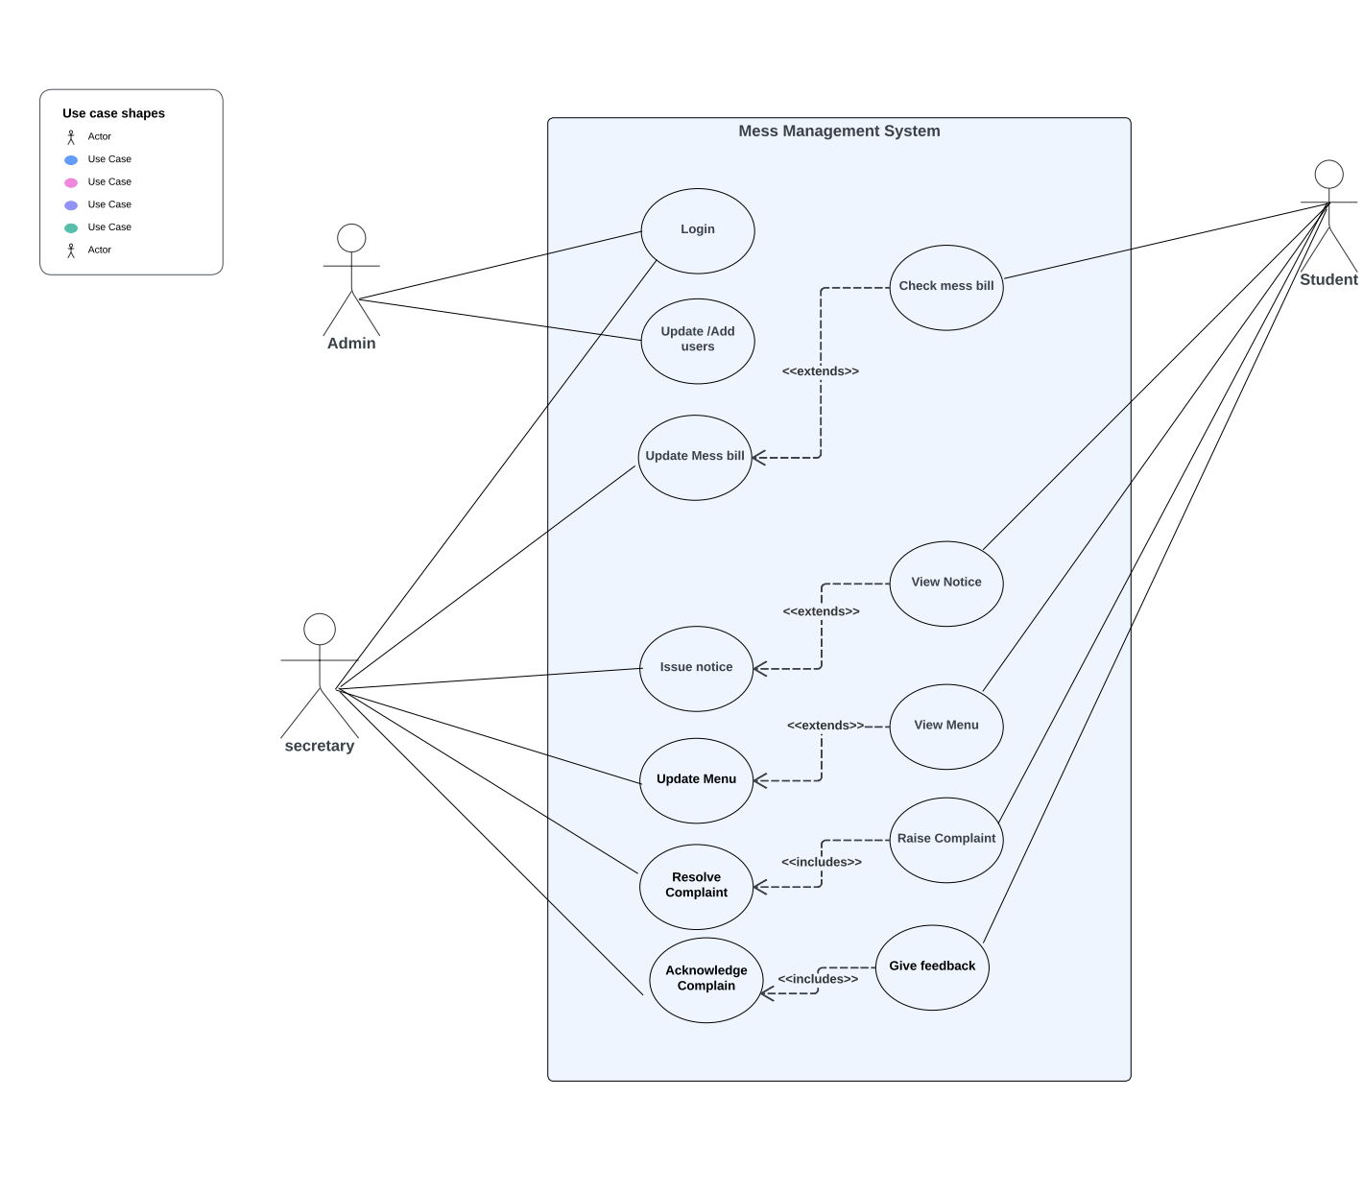

### Use Case #1 (Resolve Complaints)

|  |  |  |  |  |
| --- | --- | --- | --- | --- |
| **Use Case ID:** | P02: Mess Maintenance System | | | |
| **Use Case Name:** | Resolve Complaint | | | |
| **Process Owner:** | Shubham Verma | | **Last Updated By:** | Shubham Verma |
| **Date Created:** | 08-01-2024 | | **Date Last Updated:** | 19-01-2024 |
| **Business Actor:** | | Admin, Secretary | | |
| **Description:** | | Students raised complaint regarding different issue faced, which either the admin or secretary will work on to resolve the problem. | | |
| **Preconditions:** | | User must be login | | |
| **Postconditions:** | | Complaint resolved successfully. | | |
| **Performance Goal:** | | Complaints are always resolved seamlessly. | | |
| **Basic Workflow:** | | 1. The student submits a complaint through the system. 2. The system records the complaint and assigns it to an administrator or staff member. 3. The administrator or staff member reviews the complaint and investigates it further if necessary. 4. The administrator or staff member takes appropriate action to resolve the complaint (e.g., providing a response, offering a solution). | | |
| **Alternative Workflow:** | | Hostel secretary will take action, if resolving issue is under his powers. | | |
| **Category:** | | Admin goal. | | |
| **Risks:** | | Student may give wrong complaints. | | |
| **Possibilities:** | | Student complaint may not be resolved. | | |
| **Special Requirements:** | | Student should be in the mess database to raise a complaint. | | |
| **Assumptions:** | | Student is in the mess database and has raised an issue. | | |
| **Notes and Issues:** | | Student must raise a proper complaint. | | |

### Use Case #2 (Update/ add user)

|  |  |  |  |  |
| --- | --- | --- | --- | --- |
| **Use Case ID:** | P02: Mess Maintenance System | | | |
| **Use Case Name:** | Update/ add user | | | |
| **Process Owner:** | Shubham Verma | | **Last Updated By:** | Shubham Verma |
| **Date Created:** | 10-01-2024 | | **Date Last Updated:** | 21-01-2024 |
| **Business Actor:** | | Admin | | |
| **Description:** | | Admin updates the student list of the currently enrolled students for the mess facility. | | |
| **Preconditions:** | | Admin must be login | | |
| **Postconditions:** | | Admin will be given a prompt of “Student list updated successfully” and the updated student list will be displayed. | | |
| **Performance Goal:** | | All the new students are added seamlessly. | | |
| **Basic Workflow:** | | 1. User/admin will login into the system. 2. He will check whether there is any new enrolment. 3. He will update the student list. 4. After updating, the new student list will be displayed. | | |
| **Alternative Workflow:** | |  | | |
| **Category:** | | Admin goal | | |
| **Risks:** | | Old students have not opted out of the mess facility. | | |
| **Possibilities:** | | Student may already be in the mess database. | | |
| **Special Requirements:** | | Admin should know the details of the old/new students. | | |
| **Assumptions:** | | New student has enrolled for the mess facility. | | |
| **Notes and Issues:** | | Admin should fill the student details correctly. | | |

### Use Case #3 (View Mess Bill)

|  |  |  |  |  |
| --- | --- | --- | --- | --- |
| **Use Case ID:** | P02: Mess Maintenance System | | | |
| **Use Case Name:** | View Mess Bill | | | |
| **Process Owner:** | Shubham Verma | | **Last Updated By:** | Shubham Verma |
| **Date Created:** | 11-01-2024 | | **Date Last Updated:** | 27-01-2024 |
| **Business Actor:** | | Student | | |
| **Description:** | | Student checks his/her monthly mess bills along with extra expenses. | | |
| **Preconditions:** | | Student must be login | | |
| **Postconditions:** | | Student will see the table of the mess bill for every month along with his/her extra expenses. | | |
| **Performance Goal:** | | Mess bill is shown correctly for the specified student. | | |
| **Basic Workflow:** | | 1. Student will login into the system.   1. Student will check for his/her mess bill. 2. Mess Bill table shown successfully. | | |
| **Alternative Workflow:** | |  | | |
| **Category:** | | Student goal | | |
| **Risks:** | | Bill amount not fetched correctly from mess database. | | |
| **Possibilities:** | |  | | |
| **Special Requirements:** | | Student should have a mess account. | | |
| **Assumptions:** | | Student is logged in into the mess system. | | |
| **Notes and Issues:** | | Admin should fill the student bill correctly. | | |

**Architectural Design**

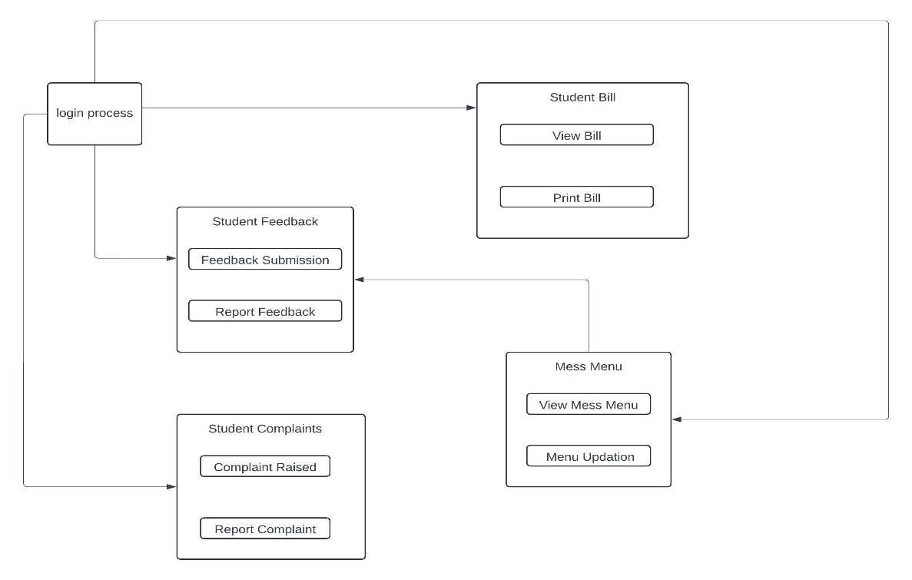

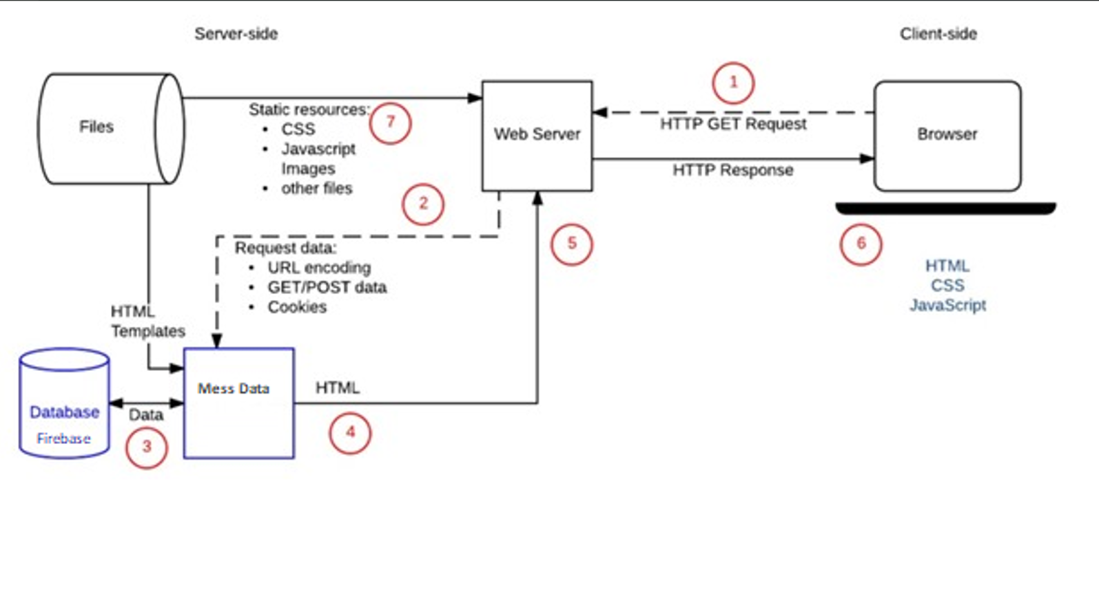

**Lab Assignment No. 2) Draw a DFD for the given case study. Also prepare an IEEE-SRS. (2+4)**

Solution: -

DFD Diagram

**Level 0 DFD**

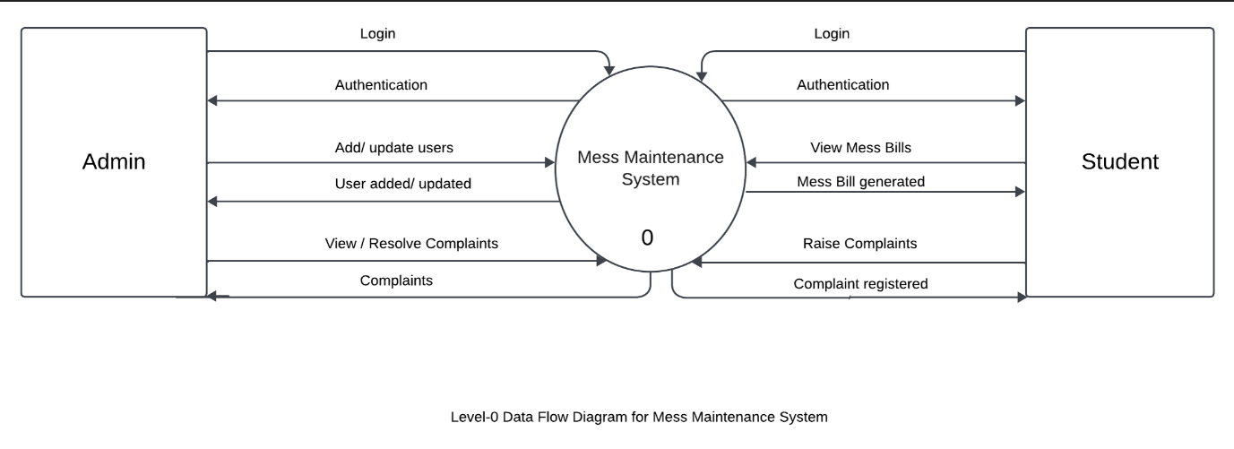

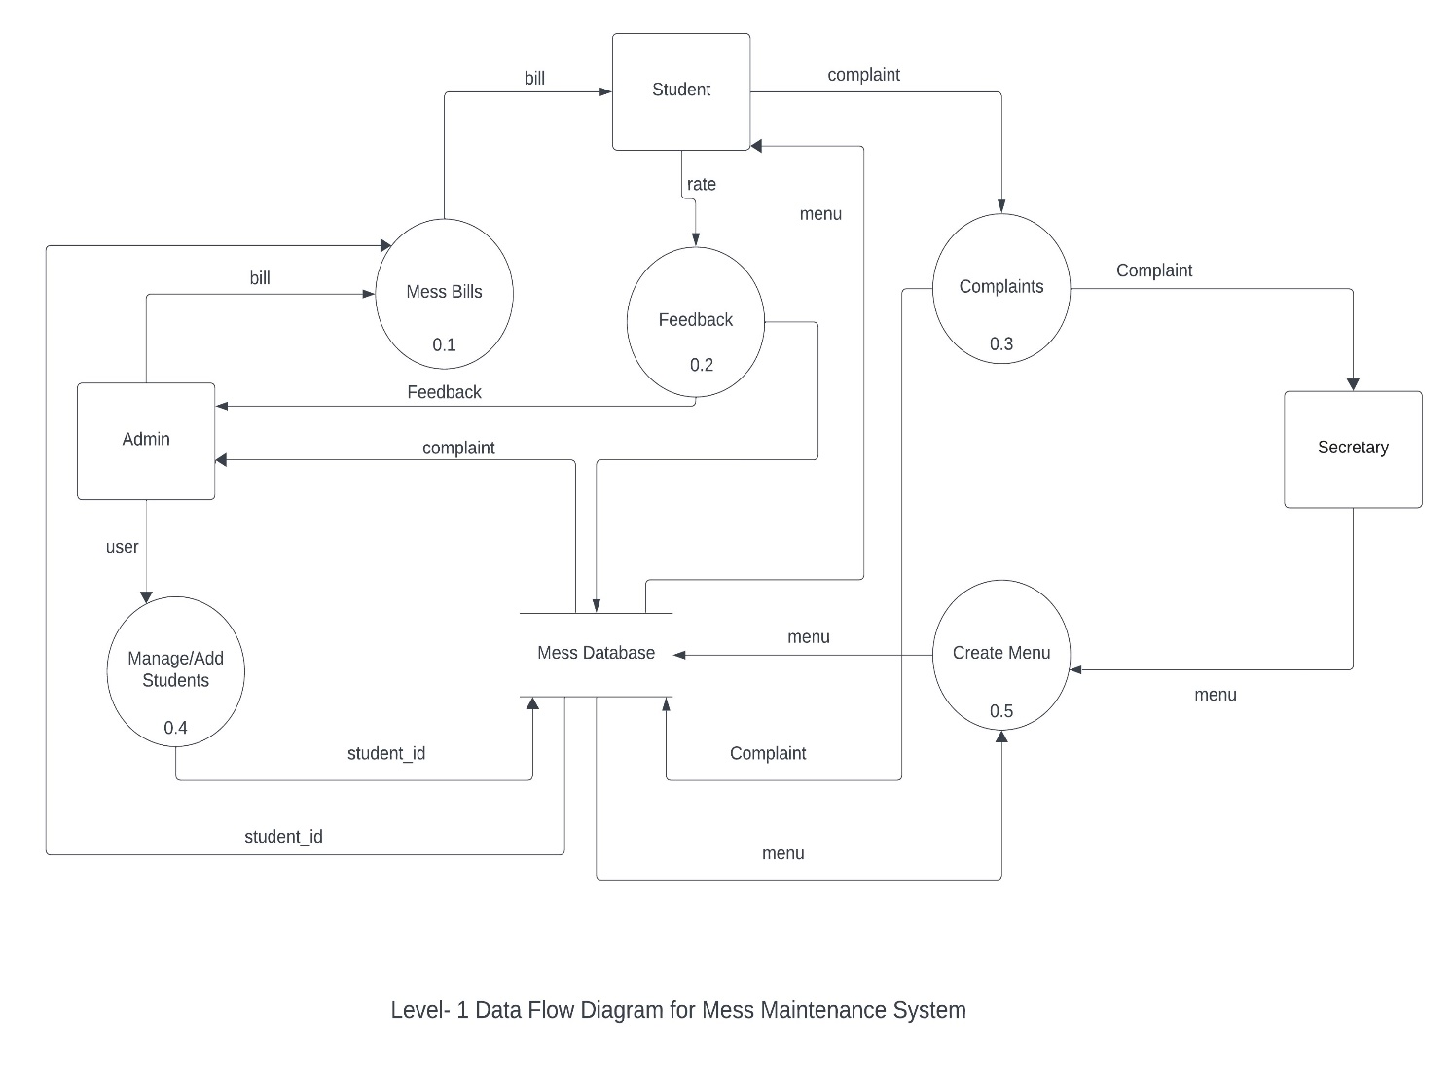**Level 1 DFD**

**Level 2 DFD**

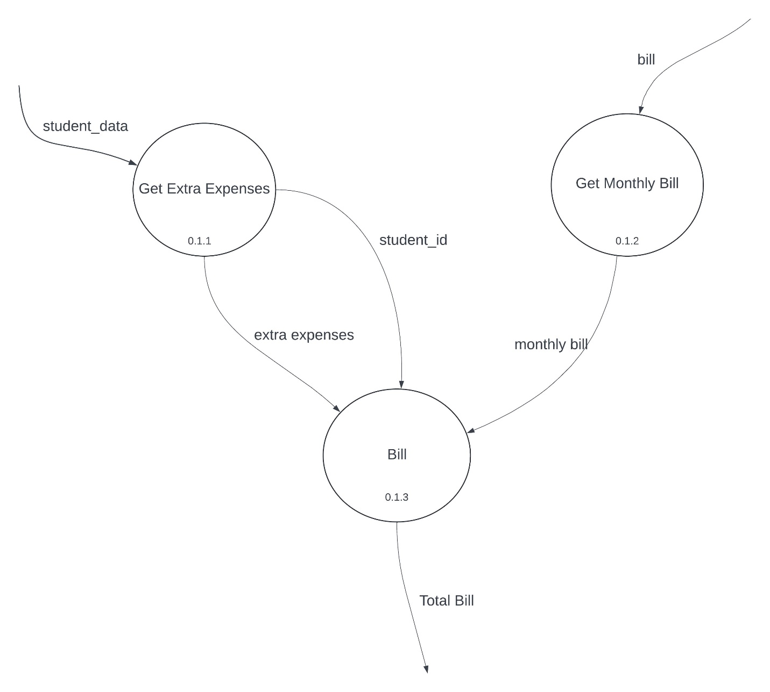

Software Requirements Specification

for

Mess Maintenance System

Version 1.0

Prepared by:

Group Name: project 2

|  |  |  |
| --- | --- | --- |
| AAKASH CHAUDHARY | MCA/10034/23 | [aakash02teotia@gmail.com](mailto:aakash02teotia@gmail.com) |
| HARSH RAJ | MCA/10011/23 | [harshrajhzb@gmail.com](mailto:harshrajhzb@gmail.com) |
| SHUBHAM VERMA | MCA/10012/23 | [mca10012.23@bitmesra.ac.in](mailto:mca10012.23@bitmesra.ac.in) |
| UTKARSH KUMAR | MCA/10002/23 | [Itsutkarsh06@gmail.com](mailto:Itsutkarsh06@gmail.com) |
|  |  |  |

|  |  |
| --- | --- |
| Instructor: | *K. S PATNAIK* |
| Course: | MCA |
| Lab Section: | *A* |
| Teaching Assistant: | Dr. K.S Patnaik |
| Date: | 09th April, 2024 |

Contents

Contents ii

Revisions ii

1 Introduction 19-20

1.1 Document Purpose 19

1.2 Product Scope 19

1.3 Intended Audience and Document Overview 19

1.4 Definitions, Acronyms and Abbreviations 20

1.5 Document Conventions 20

1.6 References And acknowledgement……………………………………………………………… .20

2 Overall Description 21

2.1 Product Overview 21

2.2 Product Functionality 21

2.3 Design and Implementation Constraints 21

2.4 Assumptions and Dependencies 21

3 Specific Requirements 22-27

3.1 External Interface Requirements 22

3.2 Use Case Model 22-24

3.3 Functional Requirements 25-27

4 Other Non-functional Requirements 28-29

4.1 Performance Requirements 28

4.2 Safety and Security Requirements 28

4.3 Software Quality Attributes 28-29

5 Other Requirements 30-37

6 CONCLUSION …………………………………………………………………………………………...38

Revisions

| Version | Primary Author(s) | Description of Version | Date Completed |
| --- | --- | --- | --- |
| 1.0 | Shubham Verma | Deployed version 1.0 for Mess Maintenance System. | 08/04/2024 |

# 

# Introduction

.

## The mess maintenance project is initiated in response to various challenges faced in the current mess or canteen system, including issues with food quality, service efficiency. The primary objective of this project is to enhance overall user satisfaction by improving food quality, streamlining service processes. The project's scope extends to key areas such as menu planning, procurement of ingredients, food preparation and serving methodologies. Significant benefits anticipated from this project include improved operational efficiency, better adherence to health and safety standards, and potential cost savings. The methodology for implementing this project involves gathering user feedback through surveys and leveraging technology for more efficient service delivery. This project stands as a crucial step towards a more efficient and satisfactory mess maintenance system

## Document Purpose

## The purpose of a mess management project is to enhance the efficiency, quality, and overall user experience of a dining facility. This involves addressing issues such as food quality, waste management, service speed, and user satisfaction. By improving these aspects, the project aims to create a more effective and enjoyable dining environment for its users.

## Product Scope

## The product scope of a mess management project, in short, involves the development and implementation of systems and processes to improve food quality, service efficiency, waste management, and user satisfaction in a dining facility.

## Intended Audience

## This document is intended for:

## Development Team: To understand the requirements for building the Mess Maintenance System.

## Project Stakeholders: Including administrators, security personnel, and end-users who need a comprehensive understanding of the system functionalities.

## DOCTUMENT OVERVIEW

This document is organized as follows:

Section 1: Introduction

Section 2: System Overview

Provides a brief description of the Mess Maintenance System, including its purpose, objectives, and architectural overview.

Section 3: Functional Requirements

Details the specific functionalities of the system, including user authentication, access control, incident reporting, surveillance management, and emergency alerts.

Section 4: Non-Functional Requirements

Specifies the performance, security, and reliability aspects of the system.

Section 5: Constraints

Outlines the constraints that the system must adhere to, including legal and compatibility requirements.

Section 6: Conclusion

Summarizes the document and its significance in guiding the development and implementation of the Mess Maintenance System.

## Document Conventions

The following conventions are used in this document:

Bold Text: Indicates section headings and important points.

Font size: 12

Bold text on heading with underline

## References and Acknowledgments

The development of this Software Requirements Specification benefited from the collaboration and inputs of various individuals. We would like to acknowledge the efforts of the project stakeholders, including [list of names and roles], who provided valuable insights and feedback during the requirements gathering process.

The following sources were consulted during the preparation of this document:

BIT MESS WARDEN/STAFF

These references provided essential context and guidance in formulating the requirements for the Mess Management System.

# Overall Description

## Product Overview

A product overview of a mess management system includes a comprehensive solution that integrates digital tools for menu planning, inventory management, and user feedback, aimed at improving food quality, service efficiency, and waste reduction in dining facilities.

## Product Functionality

The system encompasses the following key functionalities:

Student authentication and access control.

Raised complaint by the student and try to solve by the admin.

Show mess bill to student and update by the admin/secretary.

Give feedback by the student.

## Design and Implementation Constraints

The design and implementation of the Mess Management System are subject to the following constraints:

Compatibility: The system must be compatible with common web browsers (e.g., Chrome, Firefox, Safari) and mobile devices (iOS, Android).

Legal Compliance: The system must adhere to local and national laws and regulations governing data privacy and security.

## Assumptions and Dependencies

The development team assumes the following:

Sufficient cooperation and participation from key stakeholders during system development.

Availability of necessary hardware and network infrastructure for system deployment

## Dependencies

The successful development and implementation of the Mess Management System depend on the following factors:

Availability of the required technological resources.

Integration capabilities with existing Mess infrastructure

# Specific Requirements

## External Interface Requirements

### User Interfaces

**Web-Based Interface**

The user interface shall be accessible through standard web browsers, including Chrome, Firefox, and Safari.

It shall provide an intuitive and user-friendly experience for all user roles.

**Mobile Interface**

The system shall have a responsive design for mobile devices, supporting both iOS and Android platforms.

### Hardware Interfaces

**RFID Readers**

The system shall be compatible with commonly used RFID readers.

Communication with RFID readers shall follow industry-standard protocols.

### Software Interfaces

**3.1.1 User Authentication System Integration**

The system shall integrate with the hostel student authentication system using standardized APIs.

Authentication processes shall be seamless and secure.

**3.1.2 Database Management System**

The system shall utilize a relational database management system (e.g., MySQL, PostgreSQL) for data storage.

Database interactions shall follow best practices for security and efficiency.

## Use Case Model

TO DO: Provide a use case diagram that will encapsulate the entire system and all actors.

### Use Case #1 (use case name and unique identifier – e.g. U1)

TO DO: Provide a specification for each use case diagram

**Author –** Identify team member who wrote this use case

**Purpose** - What is the basic objective of the use-case. What is it trying to achieve?

**Requirements Traceability –** Identify all requirements traced to this use case

**Priority** - What is the priority. Low, Medium, High. Importance of this use case being completed and functioning properly when system is deployed

**Preconditions** - Any condition that must be satisfied before the use case begins

**Post conditions** - The conditions that will be satisfied after the use case successfully completes

**Actors** – Actors (human, system, devices, etc.) that trigger the use case to execute or provide input to the use case

**Extends –** If this is an extension use case, identify which use case(s) it extends

**Flow of Events**

* 1. **Basic Flow - flow of events normally executed in the use-case**
  2. **Alternative** Flow - a secondary flow of events due to infrequent conditions
  3. Exceptions - Exceptions that may happen during the execution of the use case

**Includes** (other use case IDs)

**Notes/Issues** - Any relevant notes or issues that need to be resolved

food.

**3.2.2 Access Control**

The system shall manage access to hostel mess and facilities.

Access control shall include the ability to grant and revoke access permissions.

**3.2.3 Complaint**

Student shall be able to complaint regarding mess issues.

**3.2.4 Grant Permission**

Admin grant permission to Student/Secretary.

**3.2.5 Bill Updating**

Show mess bill to student and update by the admin/secretary.

**3.2.6** **Issue Notice**

The admin will issue updates regarding new mess

Use Case Model



## Functional Requirements

**R.1: Login**

**R.1.1: Login option selected**

**- Input:** “Login” option

**- Output:** User prompted to enter username and password

**- Processing:** Password Validation

**R.1.2: Validation**

**- Input:** “username and password”

**- Output:** Login successful on authentication

**R.2: Update/Add users**

**R.2.1: Update users option selected**

**- Input:** “Update users” option

**- Output:** Update successful

**- Processing:** Update the student database

**R.3: Grant Permissions**

**R.3.1: Grant Permissions option selected**

**-Input:** “Grant Permissions” option

-**Output:** Permission granted for different roles

**R.4: Update Mess Bill**

**R.4.1: Update option selected**

**-Input:**” Update Mess Bill” option

-**Output:** User prompted to upload bill

**R.4.2: Bill generation**

**-Input:** Mess bill details

**-Output:** Mess bill updated successfully

**R.5: Issue Notice**

**R.5.1: Notice option selected**

**-Input:**” Issue Notice” option

-**Output:** User prompted to upload notice

**R.5.2: Notice details**

**-Input:** Notice details

**-Output:** Notice issued successfully

**R.6: Update Menu**

**R.6.1: Update Menu option selected**

**-Input:**” Update Menu” option

-**Output:** User prompted to upload new menu

**R.6.2:**

**-Input:** New menu details

**-Output:** Menu updated successfully

**R.7: Raise Complaint**

**R.7.1: Complaint option selected**

**-Input:**” Raise Complaint/Feedback” option

-**Output:** User prompted to submit complaint

**R.7.2:**

**-Input:** Complaint details

**-Output:** Complaint submitted successfully

**R.8: Check Mess Bill**

**R.8.1: Check Bill option selected**

**-Input:**” Check Mess Bill” option

-**Output:** Mess bill details

**R.9: View Notice**

**R.9.1: View Notice option selected**

**-Input:**” View Notice” option

-**Output:** New Notice details

**R.10: View Menu**

**R.10.1: View Menu option selected**

**-Input:**” View Mess Menu” option

-**Output:** Mess Menu details

**R.11: View Complaints**

**R.11.1: View Complaints Button**

**-Input:**” View Complaint” option

-**Output:** Complaint details

# Other Non-functional Requirements

## Performance Requirements

The system shall support a minimum of 100 simultaneous users.

Response time for critical functions shall be less than 2 seconds.

**4.2 Security**

security measures in a mess management system involve implementing protocols and technologies to protect data integrity, user privacy, and prevent unauthorized access to the system, ensuring a secure and reliable operation.

**4.3 Software Quality Attributes**

**4.3.1 Reliability**

The system shall be reliable, ensuring minimal downtime and quick recovery from failures.

**4.3.2 Performance**

The system shall perform efficiently, supporting a minimum of 1000 simultaneous users.

Response time for critical functions shall be less than 2 seconds.

**4.3.3 Scalability**

The system architecture shall allow for easy scalability to accommodate future growth.

It should handle an increase in the number of connected devices and users.

**4.3.4 Security**

The system shall employ robust security measures, including encryption of sensitive data.

Access control mechanisms and authentication processes shall be resistant to unauthorized access.

**4.3.5 Usability**

The user interface shall be intuitive and user-friendly, ensuring ease of use for all stakeholders.

Mobile interfaces should provide a seamless and consistent experience.

**4.3.6 Maintainability**

The system shall be designed for easy maintenance and updates.

Changes to configurations and updates should be straightforward.

These software quality attributes outline the expectations for reliability, performance, scalability, security, usability, and maintainability of the Mess Management System. They are critical for ensuring a robust and effective system that meets the needs of the Mess community.

**4.4 Reliability**

The system shall have a backup and recovery mechanism to prevent data loss.

The system shall be available 99.9% of the time.

**5. Constraints**

The system must comply with local laws and regulations regarding data privacy and security. The system should be compatible with commonly used web browsers and mobile devices.

# Other Requirements

**5.1 Legal Requirements**

The system shall comply with all relevant local and national laws and regulations regarding data privacy, security, and surveillance.

**5.2 Documentation Requirements**

The system documentation shall include user manuals, administration guides, and technical documentation.

**5.3 Training Requirements**

The development teams shall provide training session for system administration and end-users to ensure effective utilization of the system.

Appendix A – Data Dictionary

|  |  |  |
| --- | --- | --- |
| **Field Name** | **Data Type** | **Description** |
| Login_ID | String(required) | represents an individual who interacts with the system, with different levels of access and functionality depending on their role. |
| Bill_ID | Integer | represents the bills generated for students for meals, with associated amounts and due dates, and tracking of payment status. |
| Feedback | String | represents user feedback, including ratings, along with any actions taken in response and a timestamp of when the feedback was submitted. |
| Menu_ID | String | represents the daily or weekly menu offered at the mess, with associated items and prices. |
| Complaints | String | represents a specific complaint submitted by a user, along with details, status, and a timestamp of when it was submitted. |

**Class Diagram**

Daily Expenditure

Student

Admin

Software

Feedback

Mess

Complaints

Bills

Recordkeeping

Workers

Users

Receipt

Report

Transaction Log

Grant Permission

Access

Bad Classes-

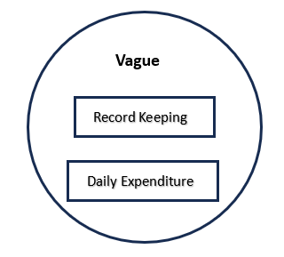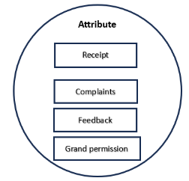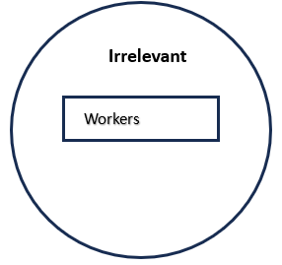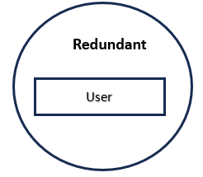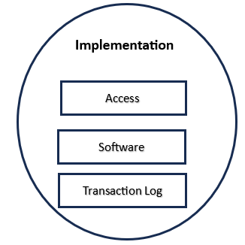

Good Classes: -



Initial Class Diagram: -

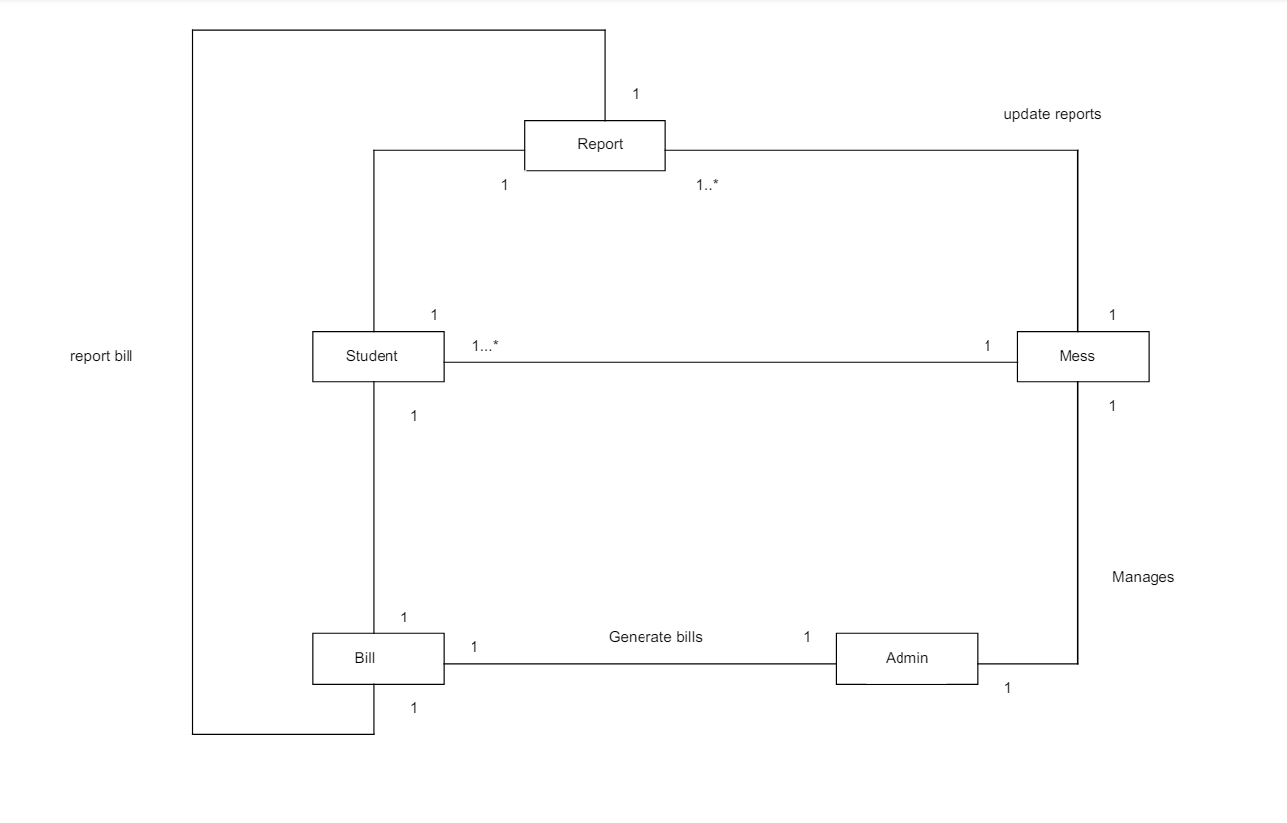

Final Class Diagram:

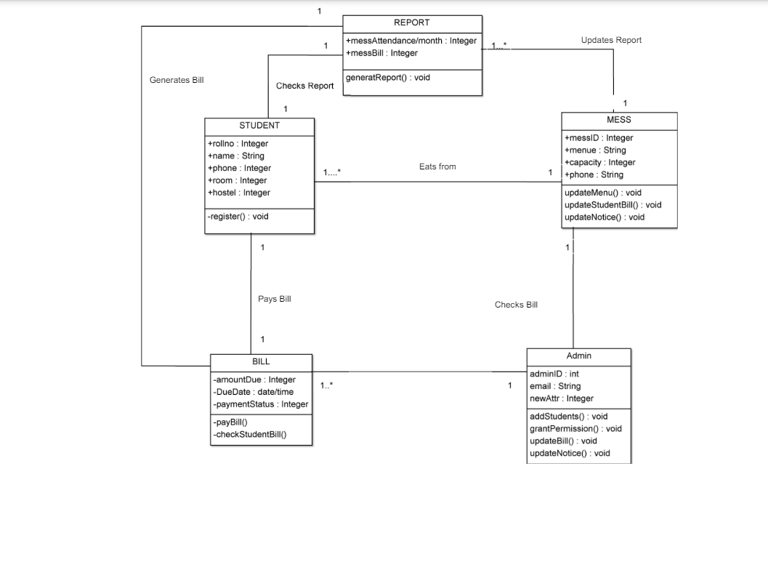

Appendix B - Group Log

**Level 0 DFD**

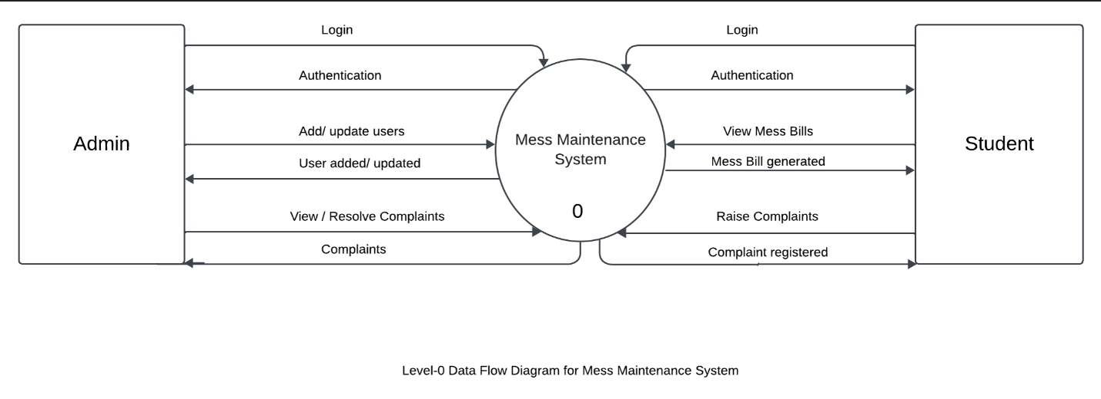

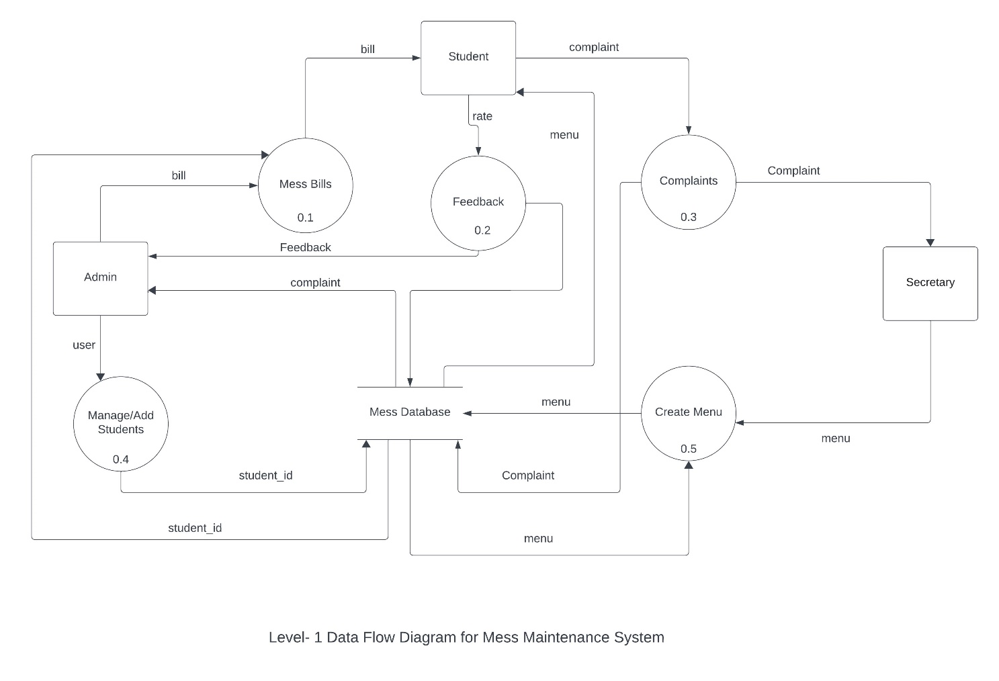**Level 1 DFD**

**Level 2 DFD**

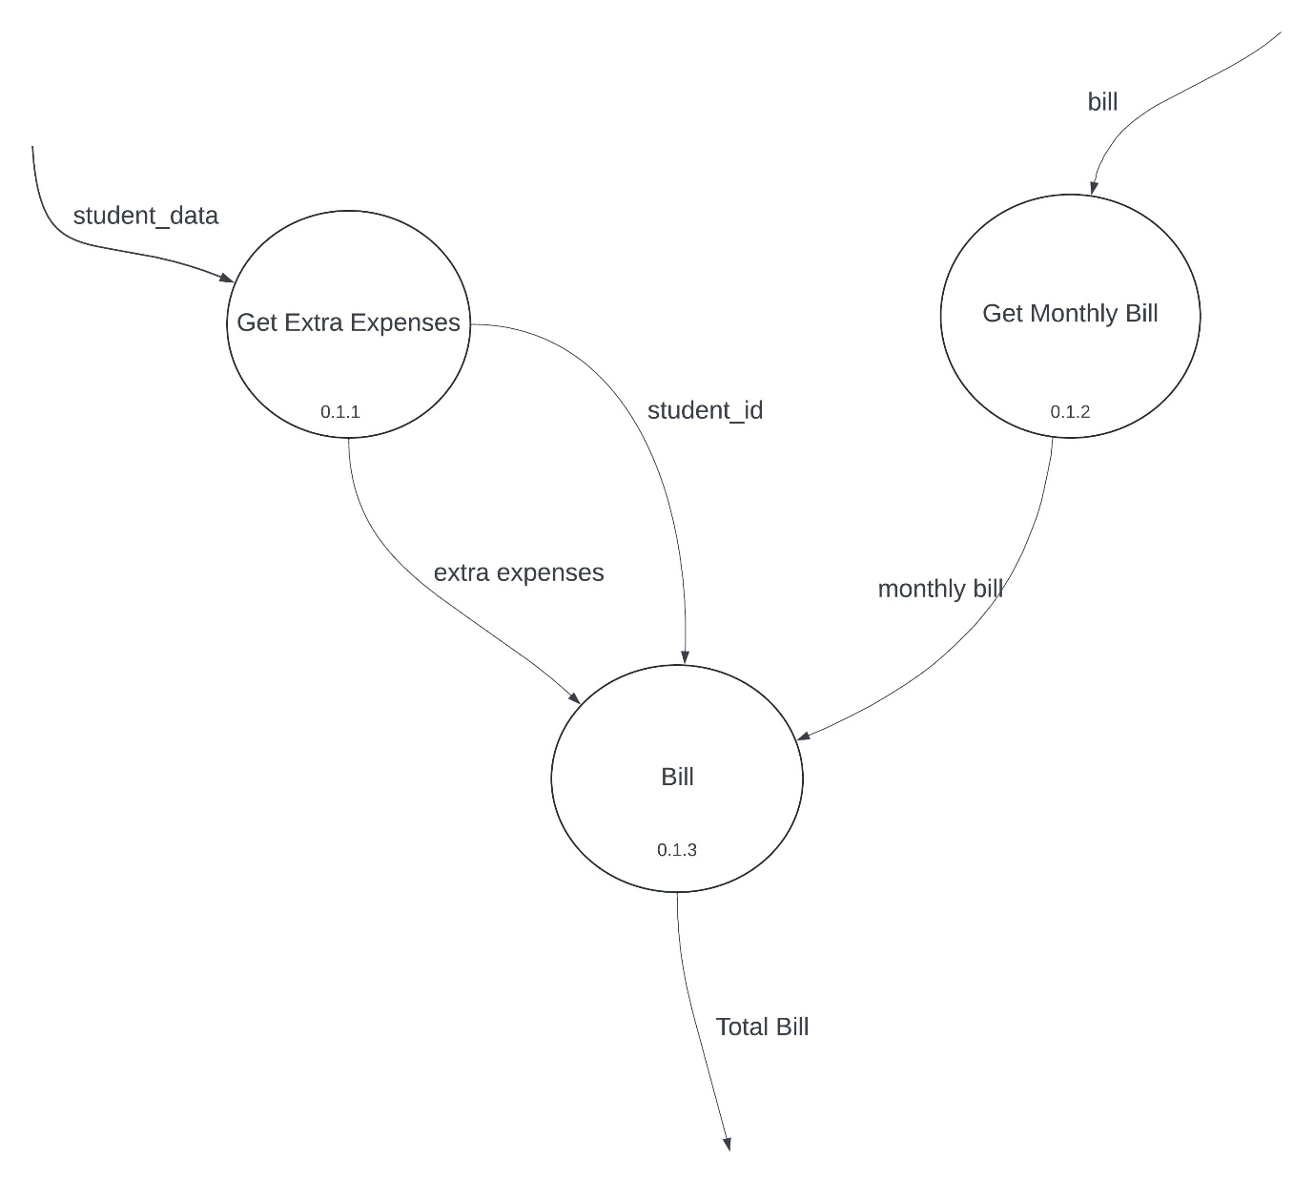

**6. Conclusion**

The conclusion of a mess management system project emphasizes the successful implementation of a comprehensive system that improves food quality, reduces waste, streamlines operations, and enhances user satisfaction in dining facilities...

**Lab Assignment No. 3) Do class analysis along with associations to prepare an initial class diagram. (2).**

Solution: -

Daily Expenditure

Student

Admin

Software

Feedback

Mess

Complaints

Bills

Recordkeeping

Workers

Users

Receipt

Report

Transaction Log

Grant Permission

Access

Bad Classes-



Good Classes: -



Initial Class Diagram: -



**4) Refine the class diagram to get the final complete class diagram. (2)**

Solution: -

Class Diagram



1

**5) Using Use case diagram and class diagram construct the interaction diagrams like sequence, collaboration and state chart diagram. (4)**

Solution: -

Sequence Diagram

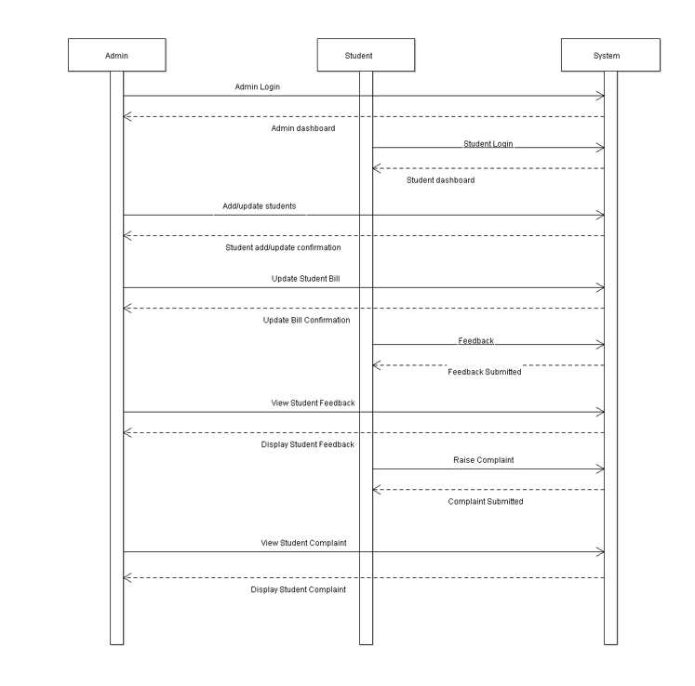

Collaboration Diagram

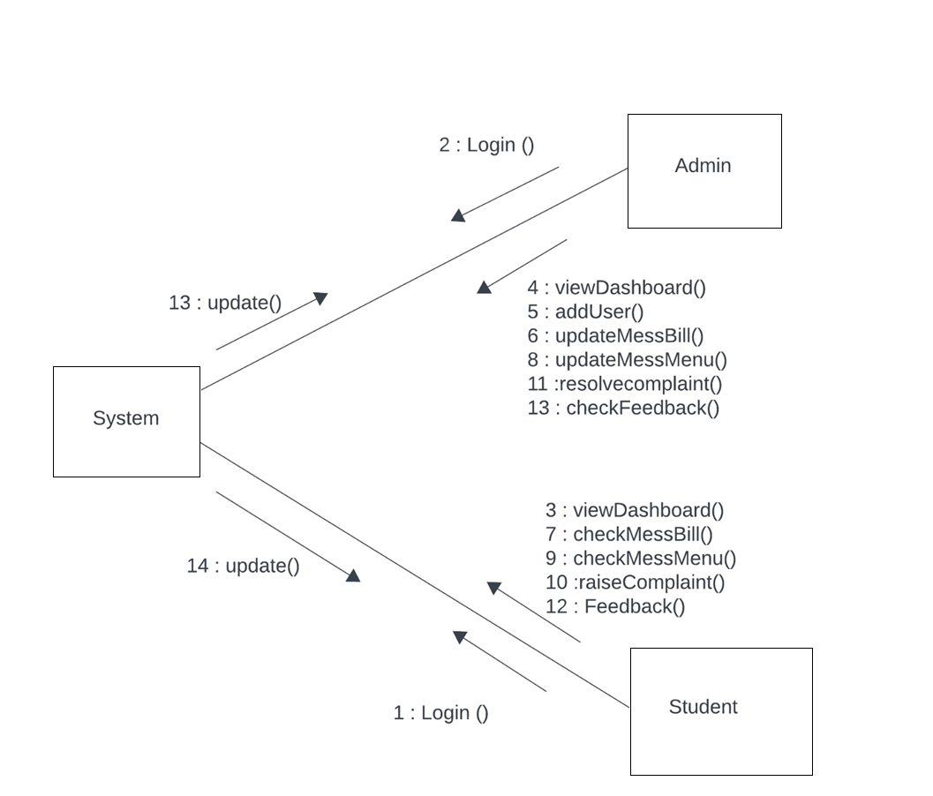

**6) Draw an Activity diagram to capture the various activities involved while capturing the behavioural aspect of the system. (2)**

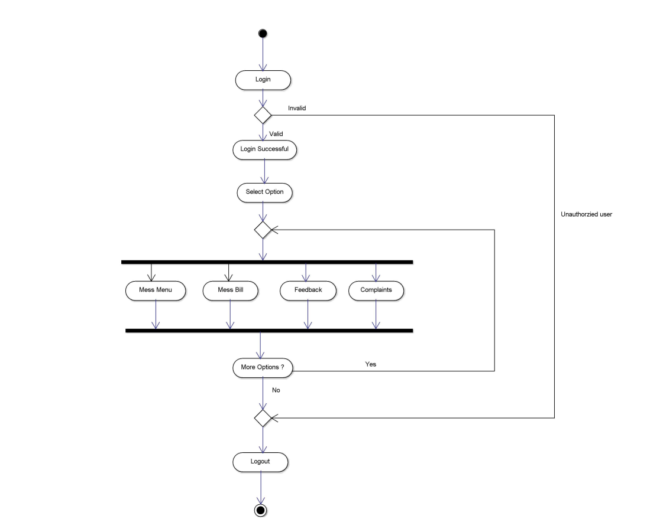

**7) Draw the component and deployment diagram to analyse the environmental and deployment view of the system. (2+2)**

Component Diagram

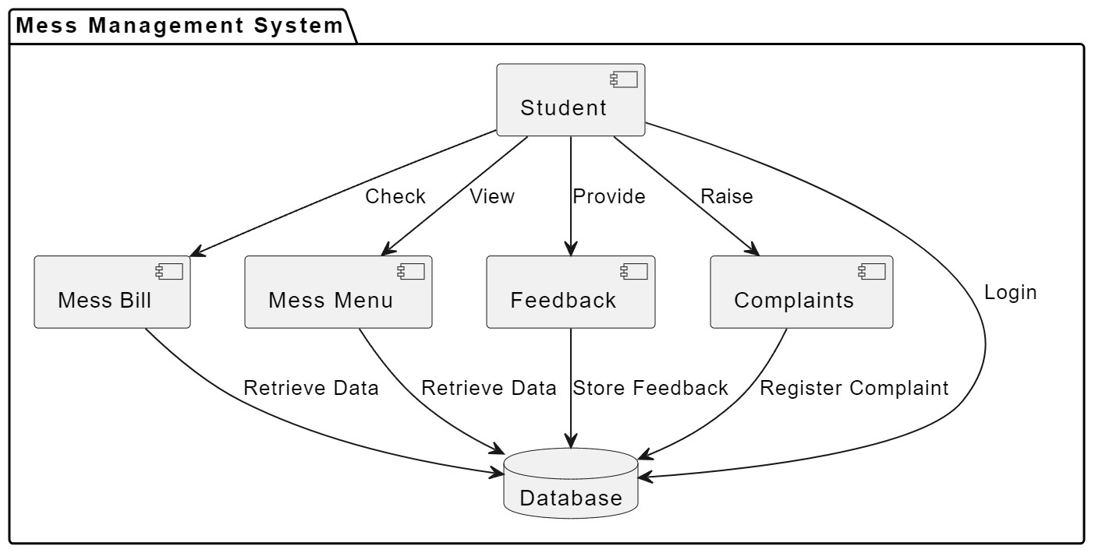

Deployment Diagram

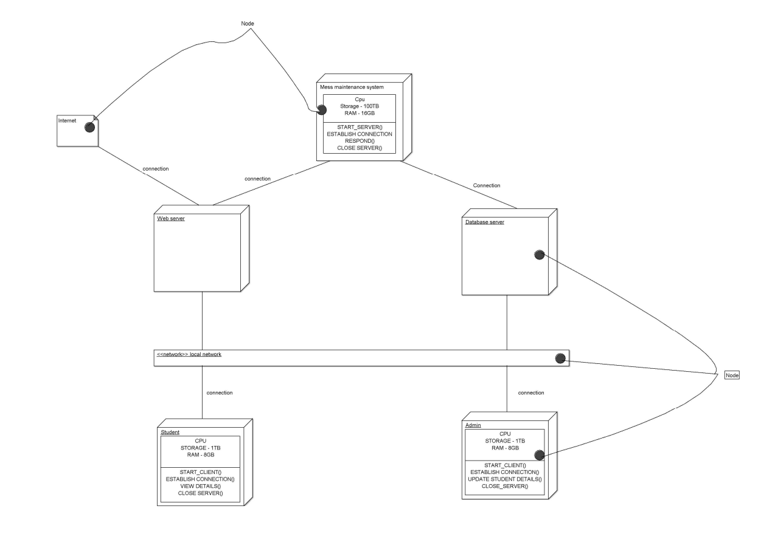

**8) Learn and analyse the usage of software testing tools.: JUnit, Selenium, TestNG, JMeter, Cucumber, PITest and JaCOCO(7).**

Junit

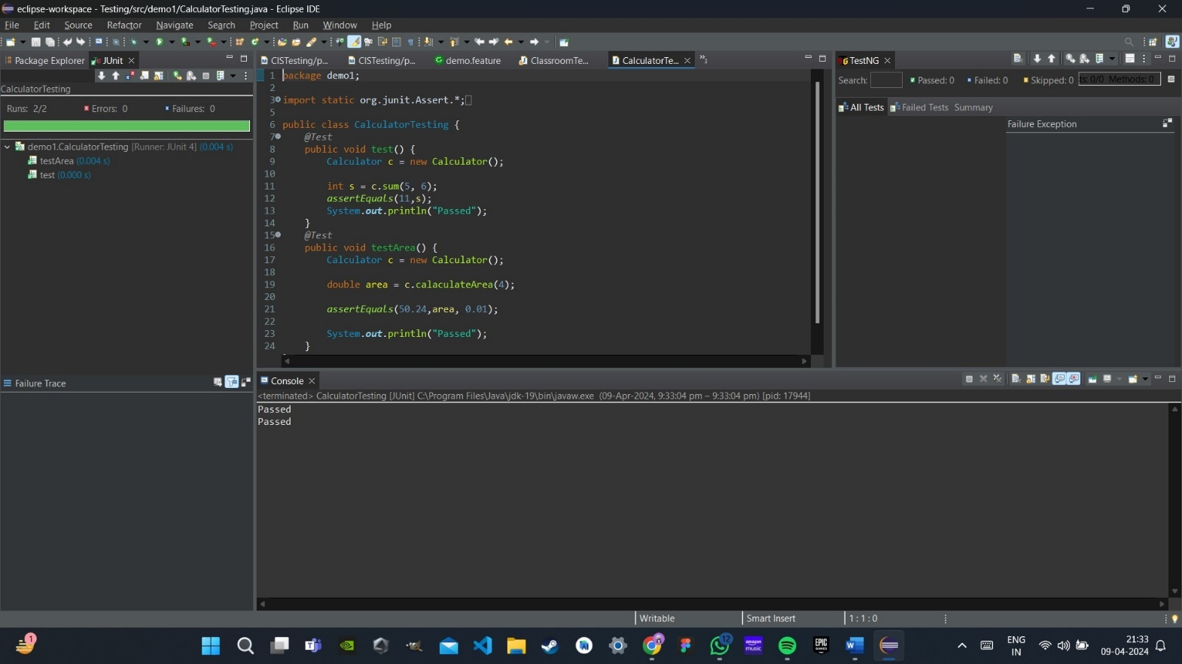

Selenium+TestNG

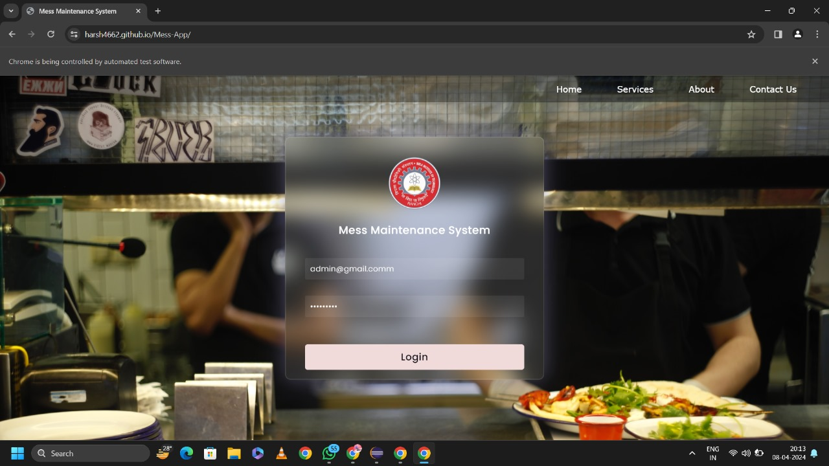

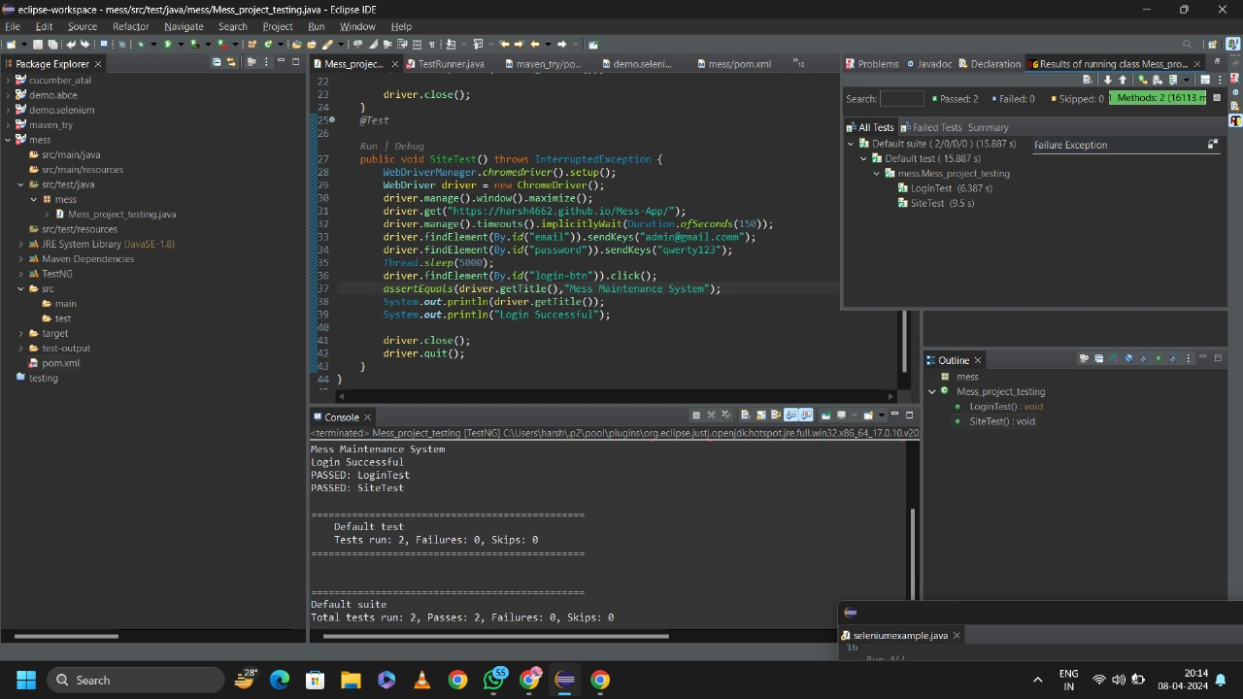

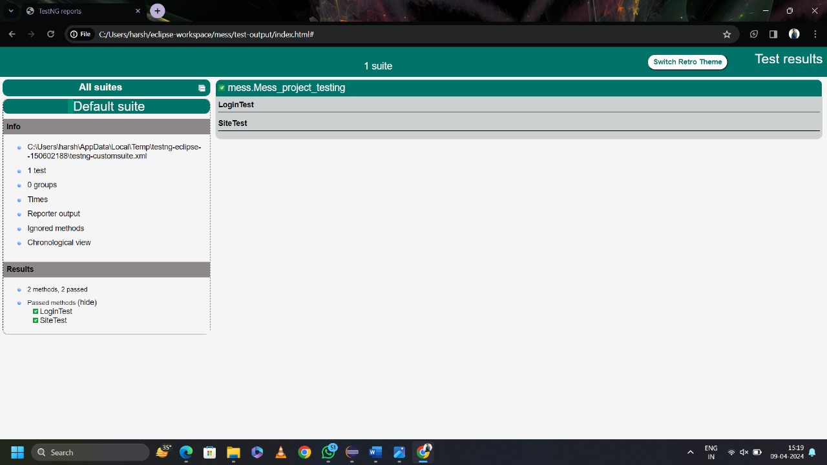

JMeter

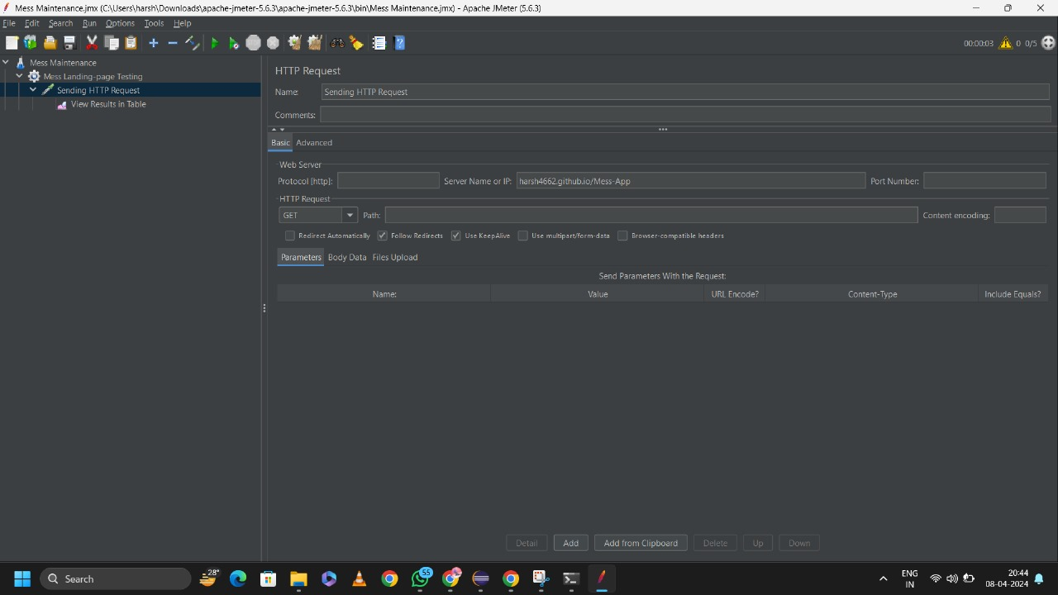

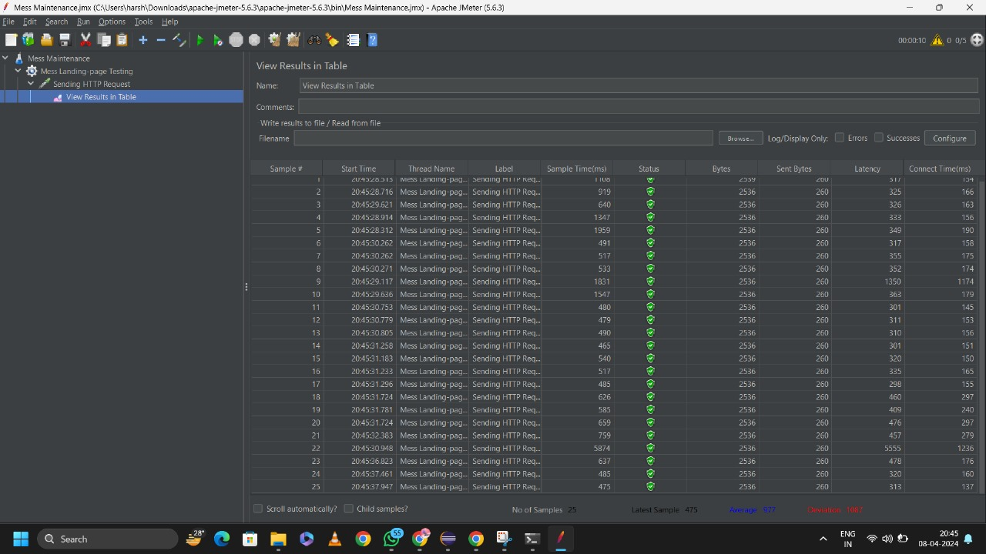

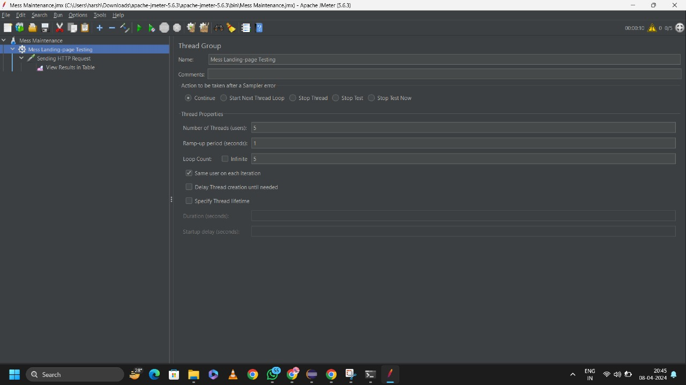

Cucumber

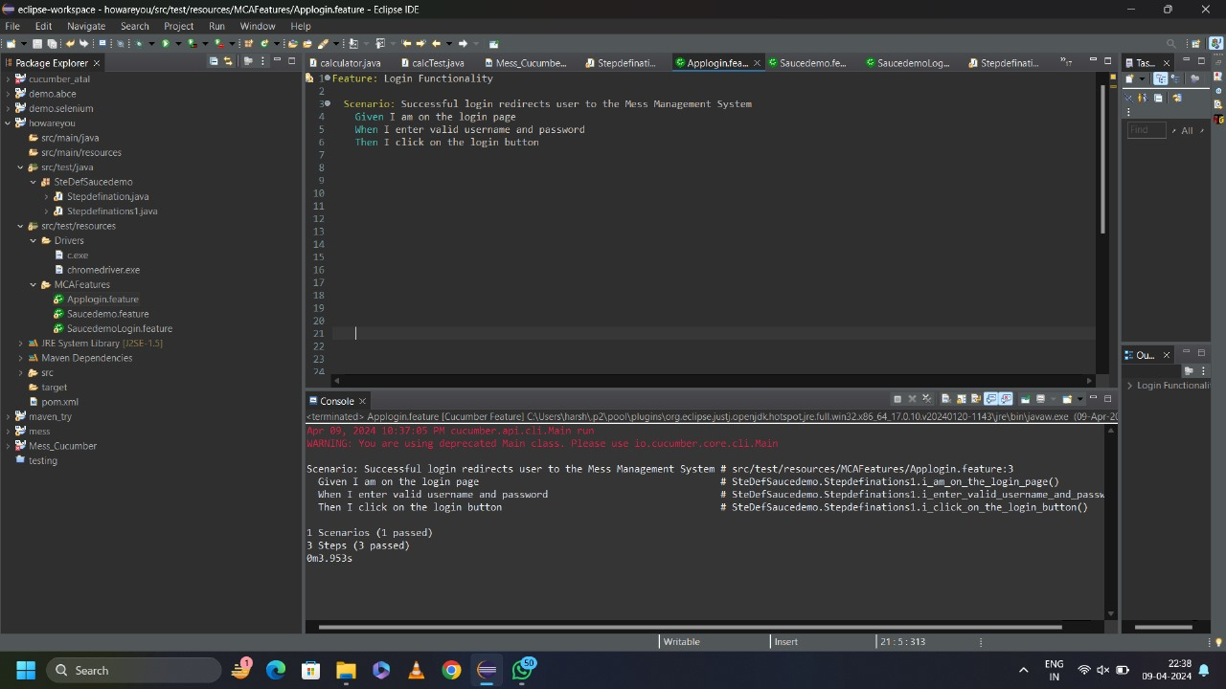

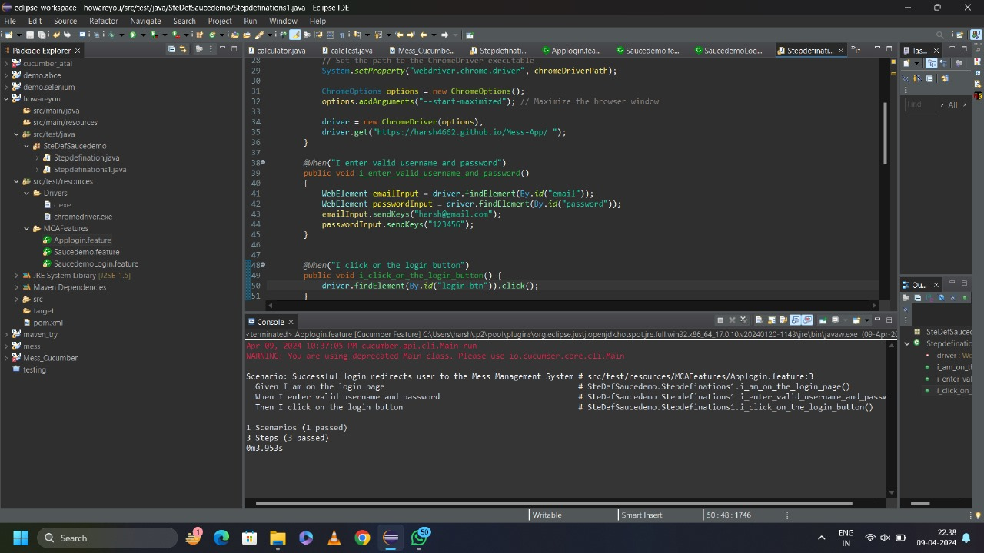

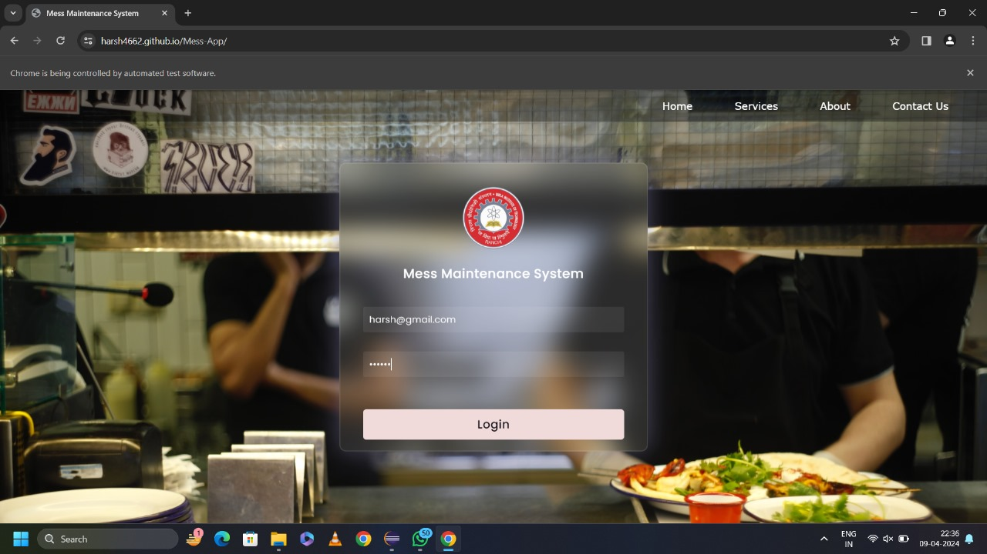

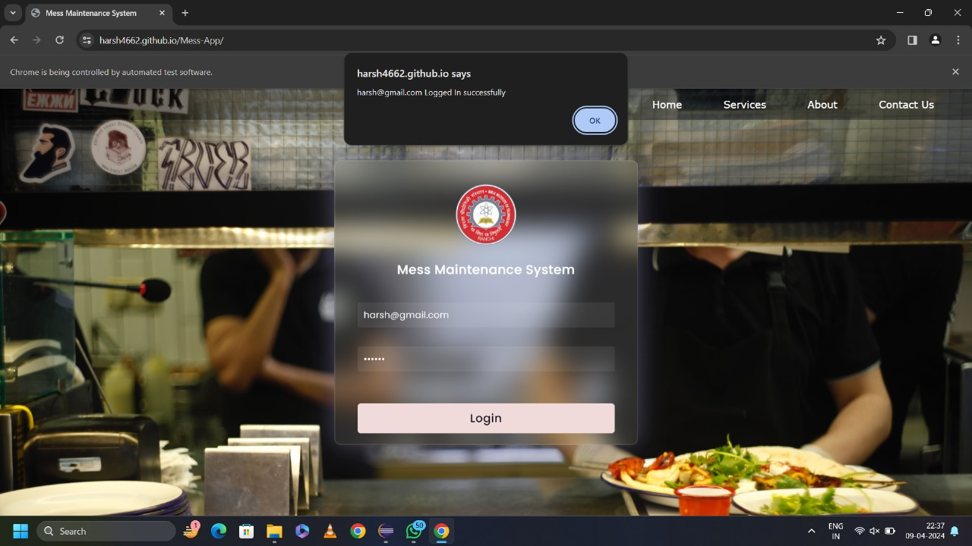

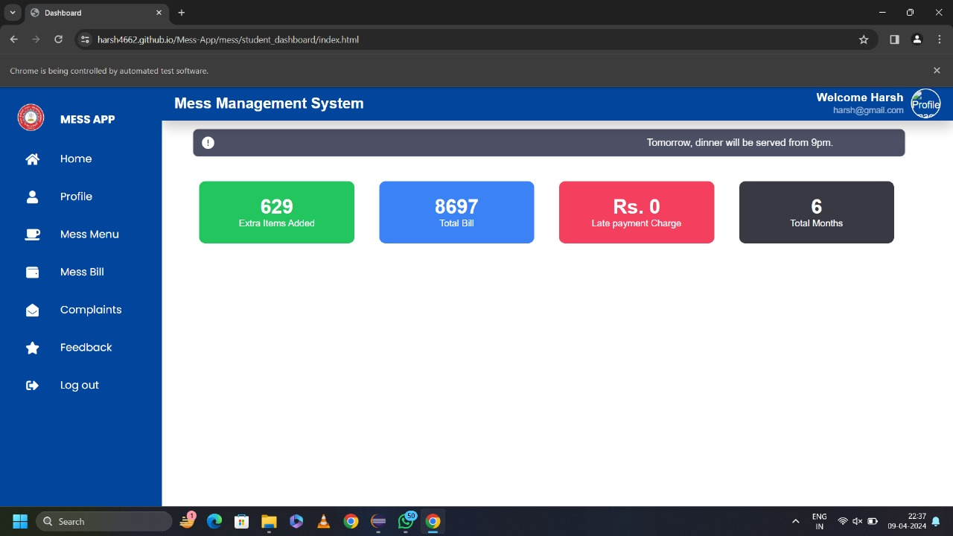

**9)Prototype development (10)**

Prototype for Mess Maintenance System is shown below:

Open index.html with live server.

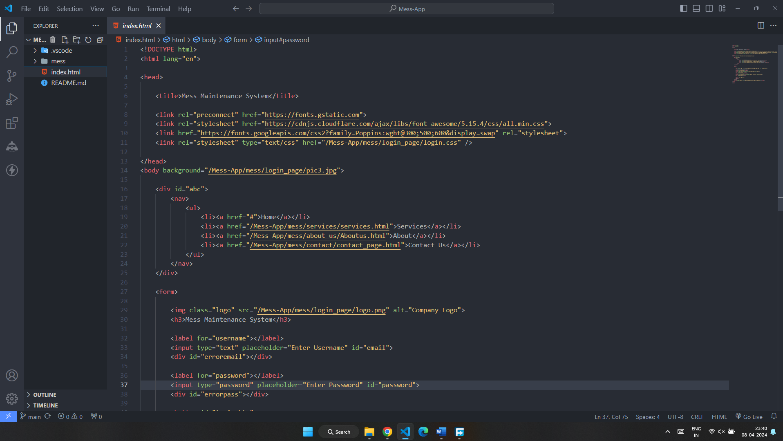

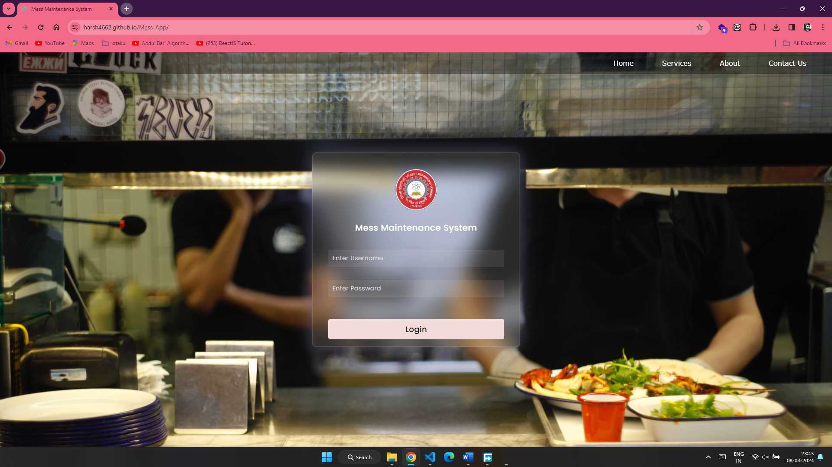Home Page

Now, user should enter username and password provided by the mess admin.

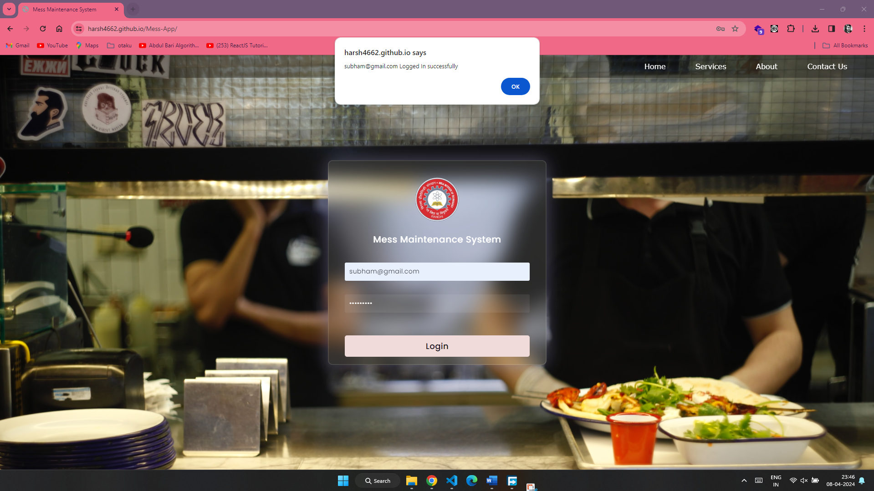

If user enters wrong username/password, it will show a popup message

“User does not exist.”

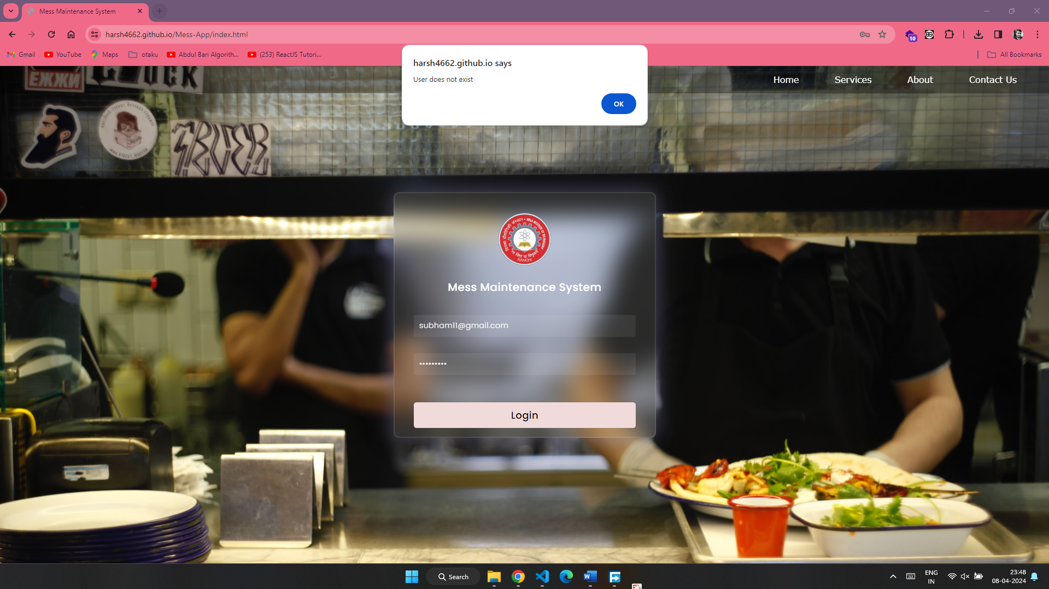

After Login successfully, you will see student dashboard.

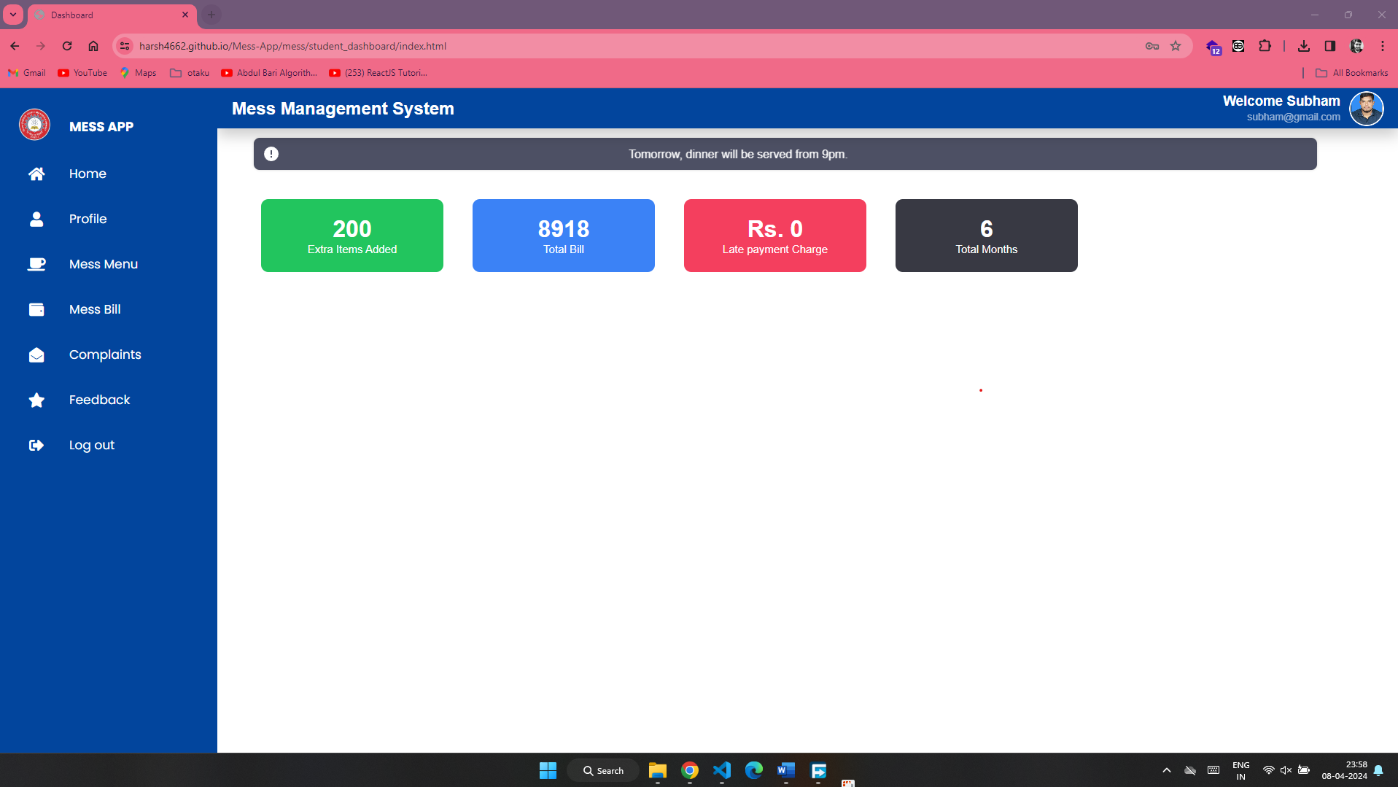

If Admin logged in, it will show Admin dashboard.

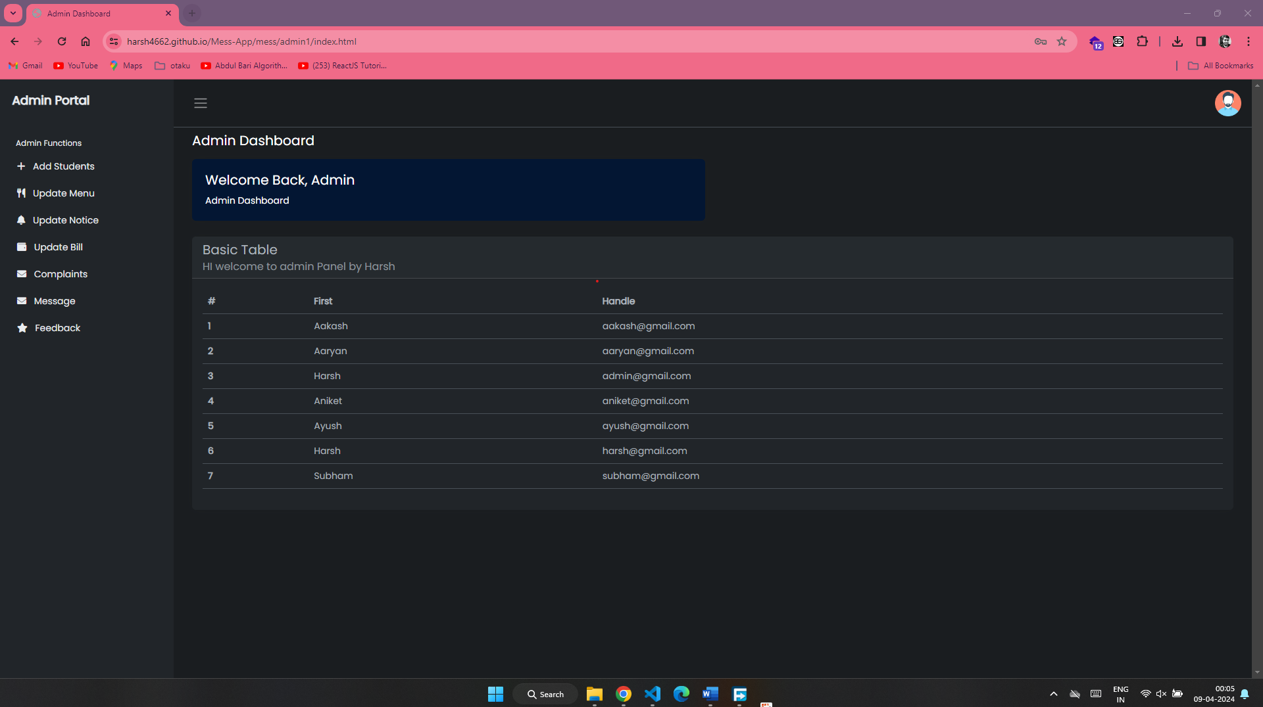

Admin can set mess menu for particular day.

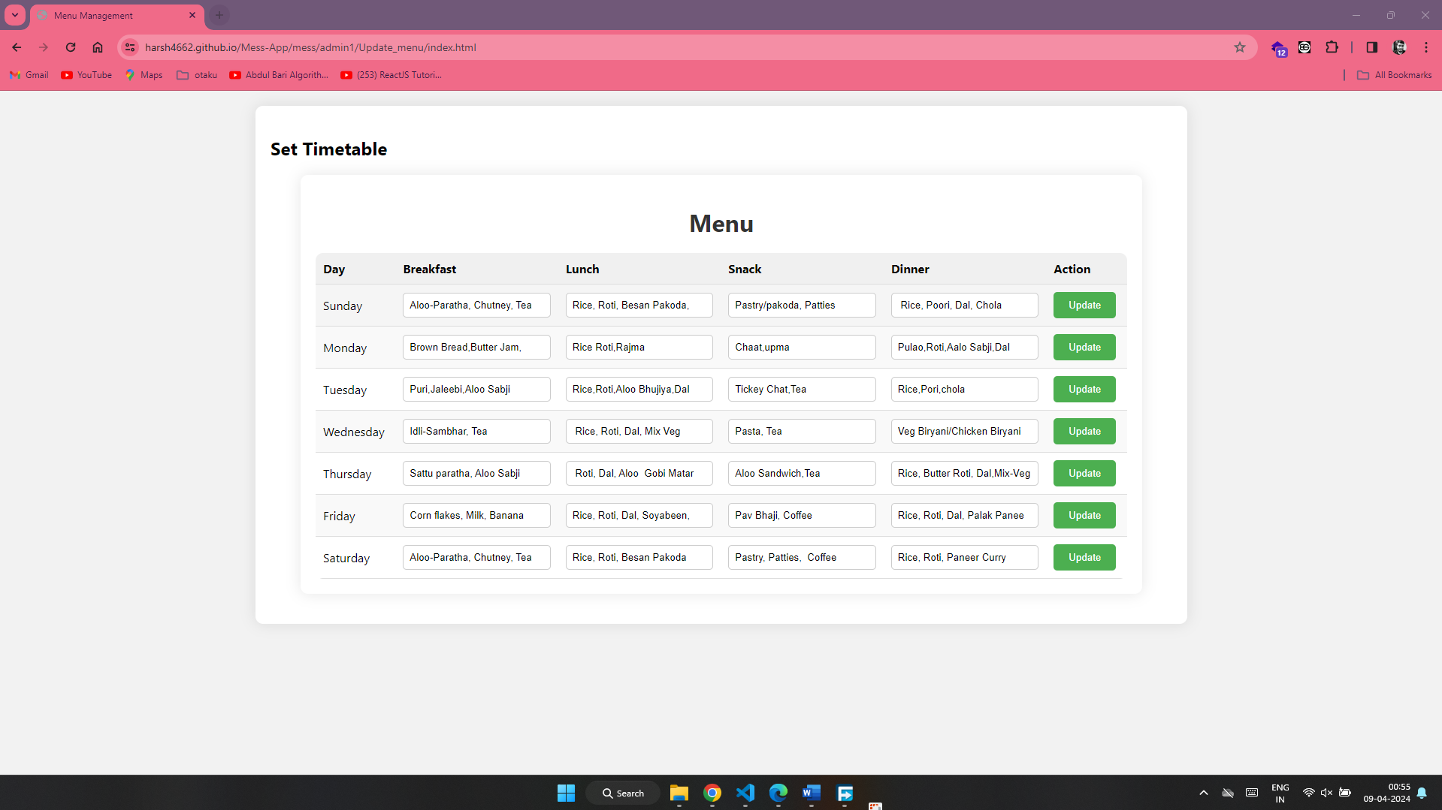

Admin can update the mess bill

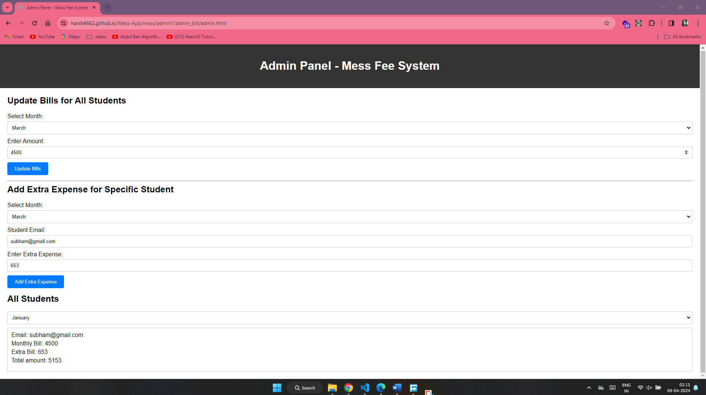

Now after updating mess bill, student can check his/her bill from student dashboard.

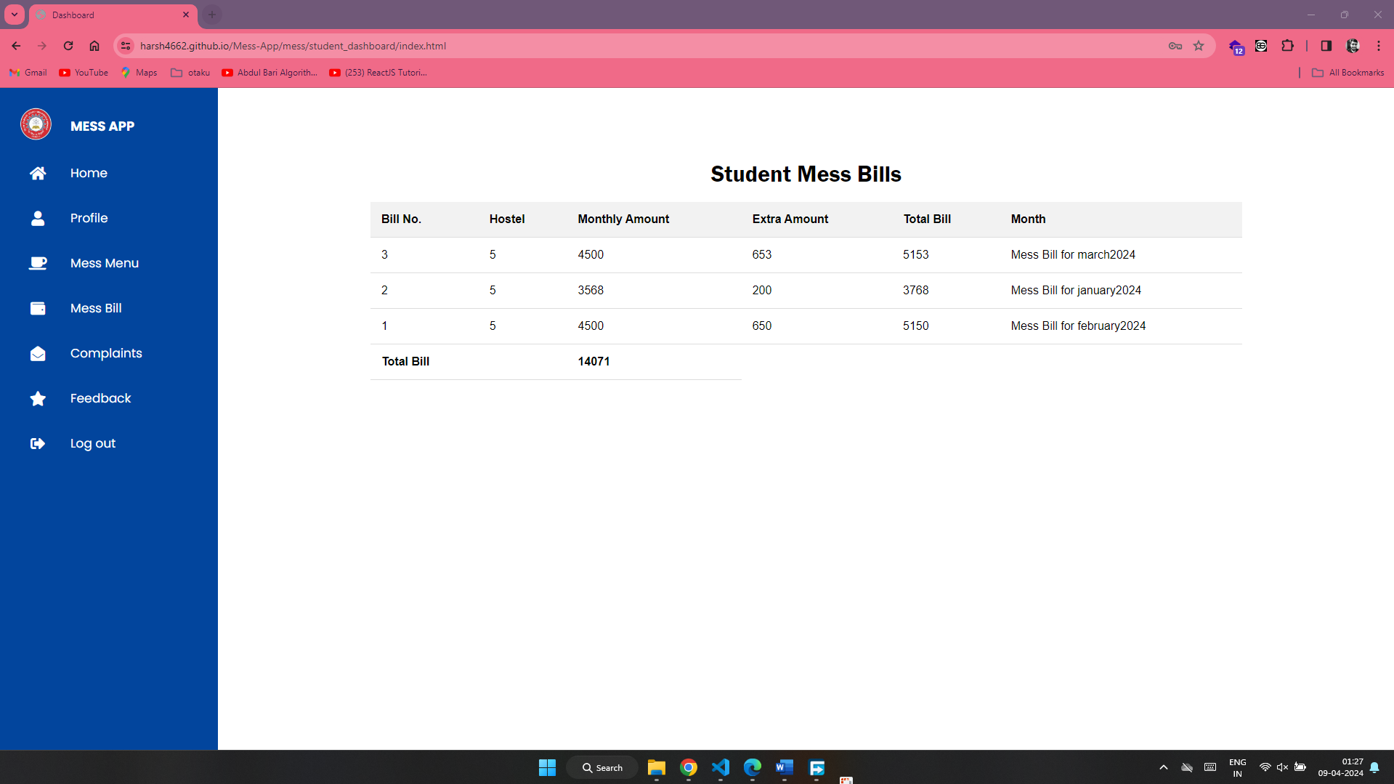

Students can also raise any complaints regarding the mess and provide feedback to improve its quality.

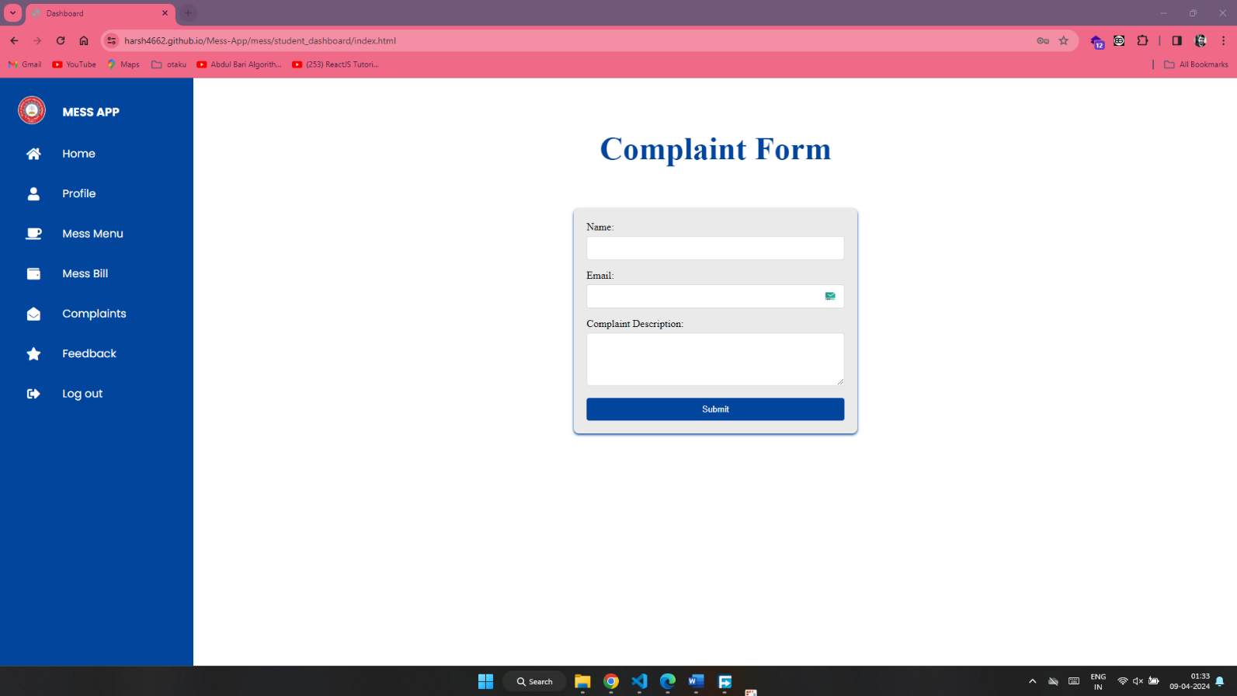

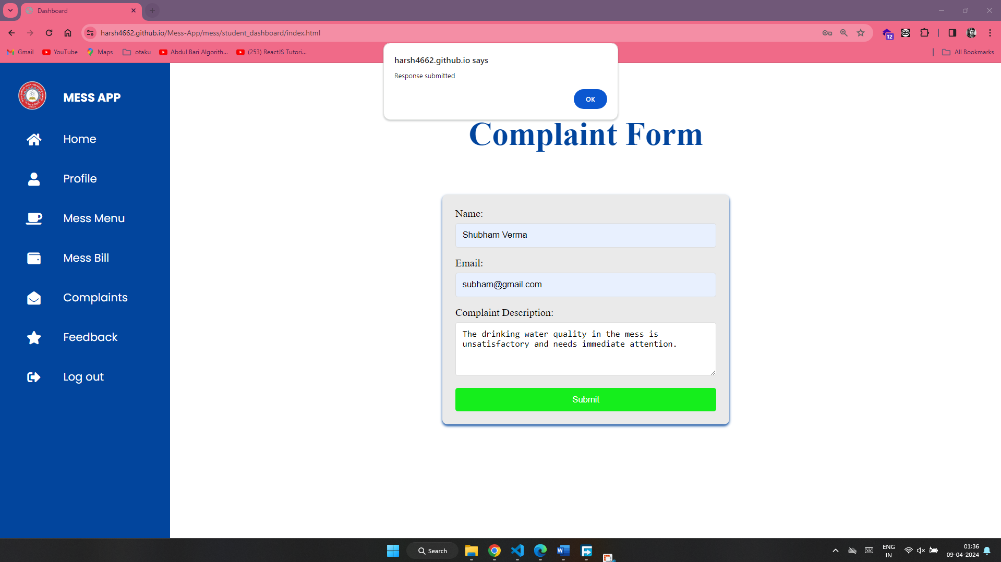

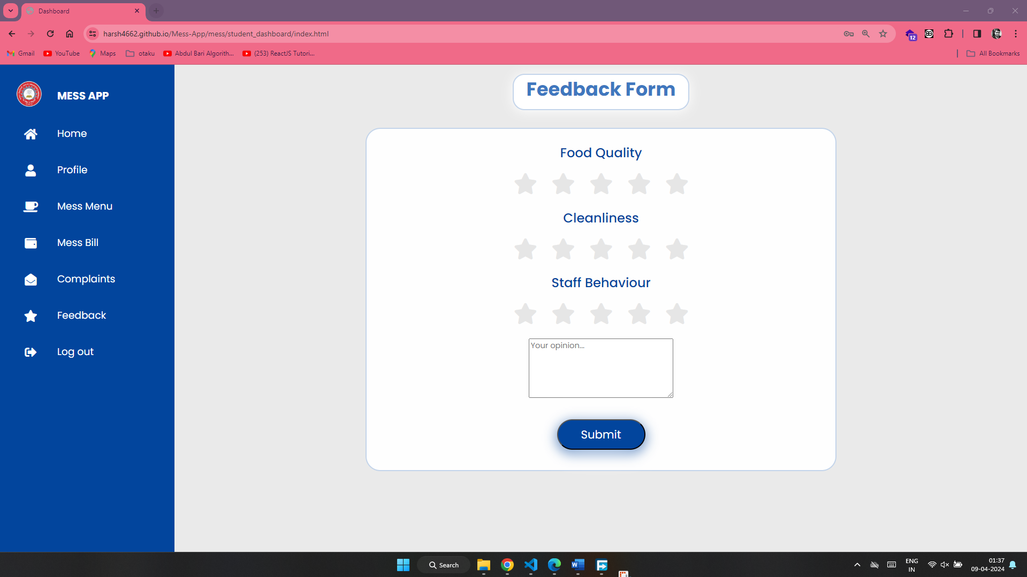

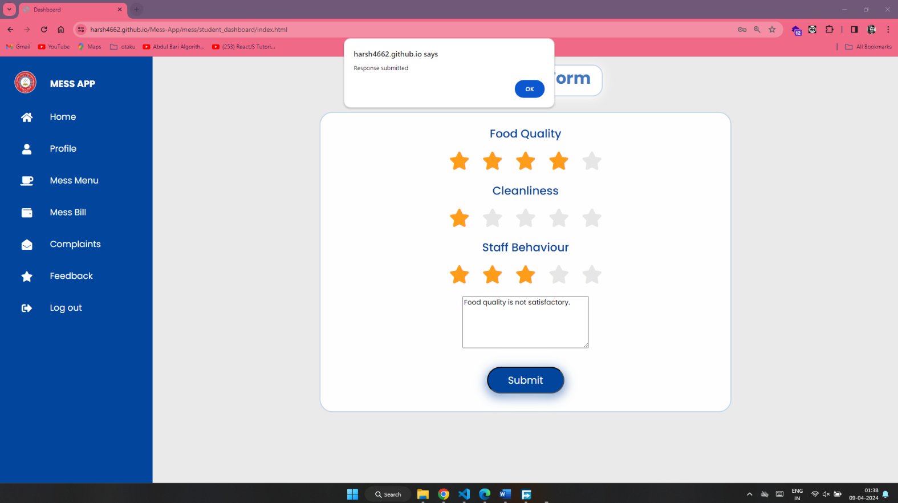

Admin can check complaints and feedback submitted by the student and tries to resolve it.

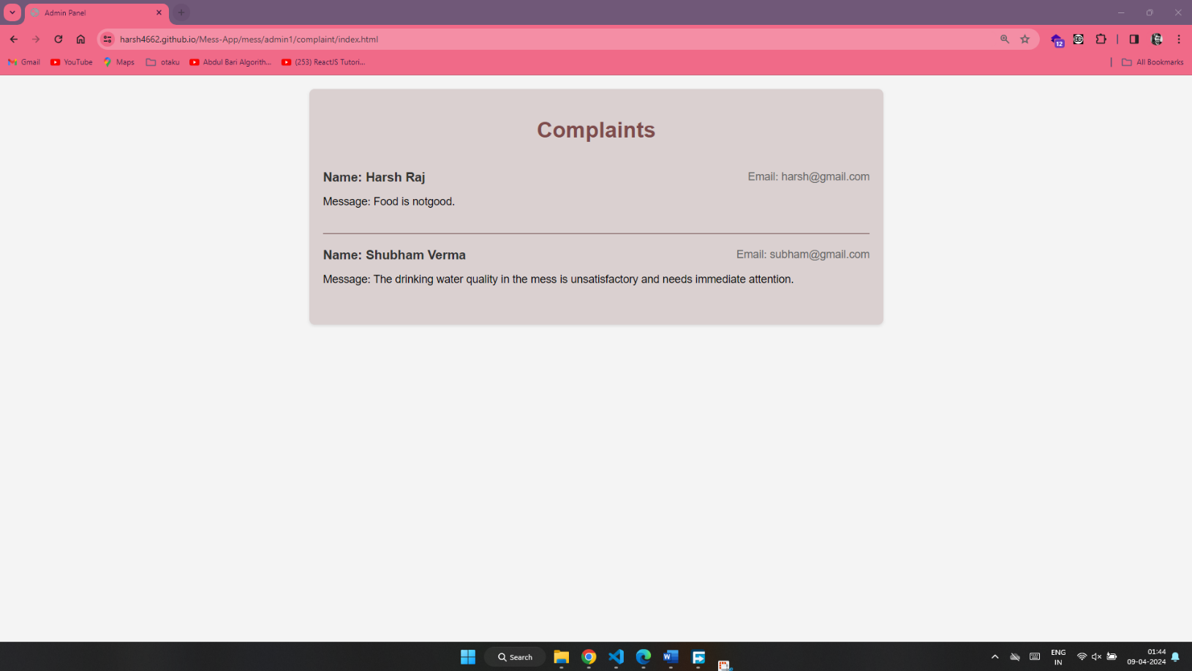

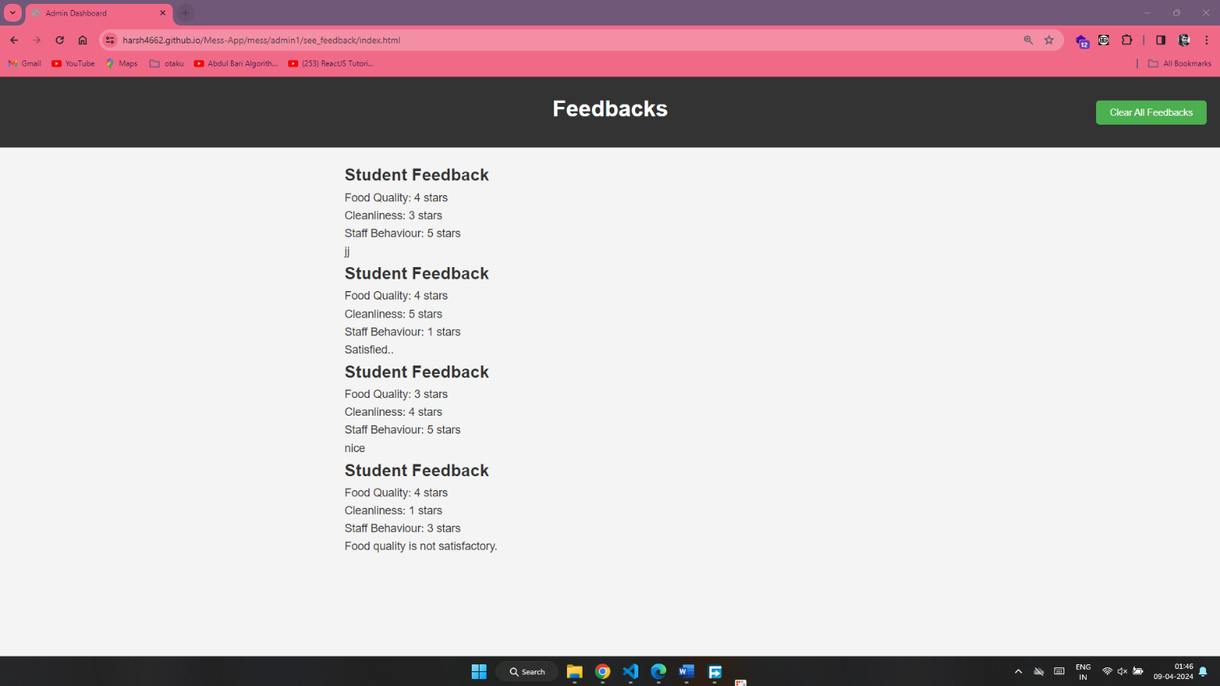

GitHub Repo: <https://github.com/v3rma9579/Mess-App>

Live Demo: <https://harsh4662.github.io/Mess-App/>

Credentials:

For Student

Username: [student@gmail.com](mailto:student@gmail.com)

Password: 123456

For Admin

Username: [admin@gmail.com](mailto:admin@gmail.com)

Password: qwerty123

**Thank You!!**